**A1: RESEARCH QUESTION**

The question I sought to answer with multiple linear regression is “which variables contribute the most to yearly customer bandwidth usage?”

**A2: GOALS**

The goal of this analysis is to examine which variables/socioeconomic factors contribute the most to bandwidth of data used per year. This is helpful to a telecommunications company since it can assist them in tailoring customer need-specific packages with optimized services and data allotments. Optimizing service packages helps keep customers satisfied and prevents them from feeling like they’re being overcharged and underserviced. Ultimately, this could be a contributing factor to customer churn patterns. However, I have chosen the scope of this specific PA task to be focused on ‘Bandwidth_GB_Year’ as the dependent variable. Therefore, there will be no further mention of ‘Churn’ in this specific PA task beyond its usage as one of the independent variables I have chosen in my initial Multiple Linear Regression model.

**B1: SUMMARY OF ASSUMPTIONS**

Multiple linear regression is based on the following assumptions (*Multiple linear regression* 2024):

* There is a linear relationship between independent and dependent variables. Scatterplots are a good way to check between the dependent and independent variables.
* Independent variables should not have high correlation with one another (multicollinearity). A good test for this assumption is the Variable Inflation Factor (VIF) method.
* Residuals have constant variance at each point of the linear model, also known as homoscedasticity. Upon analysis, standard residuals should be plotted against predicted values to check if the points are constantly distributed. Perfectly constant distribution is not required, just that the distribution is relatively constant. Significant outliers can be a key sign that the distribution may not be relatively constant. Again, scatterplots are a good test method for this assumption.
* Observations are independent of one another. In other words, residual values are independent. The Durbin Watson statistic is a method to test for this assumption.
* Residuals values show a normal distribution. A good test for this assumption is the Normal Probability plot.

**B2: TOOL BENEFITS**

I chose to use Python 3 kernel within Jupyter Notebook IDE to perform this task due to its ease of use and integration with visualization and statistical modeling. Using Python as the main programming language also enabled me to use several libraries:

* Pandas was used to easily handle large datasets
* Numpy was used in mathematical calculations and operations
* Matplotlib and Seaborn was used for visualizations
* Scipy assisted in MLR modeling (VIF for multicollinearity check) and residual graphing
* Sklearn was used for data transformation such as with One Hot Encoding

**B3: APPROPRIATE TECHNIQUE**

Multiple Linear Regression (MLR) is an appropriate technique in the application of our research question and chosen variables. The chosen dependent variable is ‘Bandwidth_GB_Year’, a continuous numerical variable. Meanwhile, the chosen independent variables are 6 nominal categorical variables and 6 continuous numerical variables: ‘InternetService’, ‘Area’, ‘Contract’, ‘Churn’, ‘Techie’, ‘TechSupport’, ‘Income’, ‘Tenure’, ‘MonthlyCharge’, ‘Outage_sec_perweek’, ‘Population’, and ‘Age’. The variables ‘InternetService’, ‘Area’, and ‘Contract’ are later converted into binary/dummy variables with OneHotEncoder for proper usage with the MLR model. ‘Churn’, ‘Techie’, and ‘TechSupport’ are converted into Booleans for proper preparation for MLR modeling. The other 6 continuous numerical variables ‘Income’, ‘Tenure’, ‘MonthlyCharge’, ‘Outage_sec_perweek’, ‘Population’, and ‘Age’ are scaled with RobustScaler for MLR model preparation purposes.

Simple linear regression is a technique that allows one to analyze and prediction relationships between two continuous variables: one independent variable and one dependent variable. MLR is an extension of this that allows analyses between multiple independent variables and a single dependent variable. This is useful in attempting to predict an outcome (the dependent variable) based on multiple independent variables (Hayes, *Multiple linear regression (MLR) definition, formula, and example*). In the case of this specific PA, out of the 12 original independent variables, 3 of these have been

Practically, MLR can be a good technique to examine relationships between other socioeconomic variables that affect Bandwidth_GB_Year, especially those that have a correlation with higher yearly data bandwidth consumption values. Additionally, it might be possible to further infer that higher bandwidth consumption could be due to certain customers being subscribed to and using bandwidth intensive services at a higher frequency if one were to attempt to think beyond the data and the simpler parameters of this current PA task. Regardless, MLR is a good tool to analyze any possible relationships between variables that could influence the higher data consumption figures.

**C1: DATA CLEANING & C4: DATA TRANSFORMATION**

Preparation of the data for MLR involves checking for nulls, duplicates, and outliers. Furthermore, MLR also requires normal distribution of data. I chose to use RobustScaler in addressing skewness and outlier treatment. It performs its task by using median and inquartile ranges to treat outliers. Furthermore, it scales variables and nonlinearly transforms them, retaining the relationship between variables (Abolirm, *Feature scaling - part 3* 2023). Many of the cleaning techniques present in this PA, such as visualization via boxplots and/or histograms, z-score calculation, etc. were used in the prior D206 Data Cleaning task.

Columns that were normalized replaced the original columns. The variable I have chosen as the dependent variable is ‘Bandwidth_GB_Year’. The following 12 variables are ones I have chosen as the independent variables in my initial MLR: ‘InternetService, ‘Area’, ‘Contract’, ‘Churn’, ‘Techie’, ‘TechSupport’, ‘Income’, ‘Tenure’, ‘MonthlyCharge’, ‘Outage_sec_perweek’, ‘Population’, ‘Age’.

Six of these variables are originally continuous numerical variables (‘Income’, ‘Tenure’, ‘MonthlyCharge’, ‘Outage_sec_perweek’, ‘Population’, ‘Age’) while the other six are originally nominal categorical variables (‘InternetService, ‘Area’, ‘Contract’, ‘Churn’, ‘Techie’, ‘TechSupport’). Therefore, One Hot Encoding via Scikit-learn’s OneHotEncoder (OHE) was necessary to transform the nominal categorical variables into continuous numerical variables that could be used in MLR modeling (Lekhana_Ganji, *One hot encoding in machine learning* 2024).

Also, the 'InternetService', 'Area', and 'Contract' columns were converted from string to category type. Boolean indexing with ‘1’ denoting ‘Yes’ and ‘0’ denoting ‘No’ was established with the following variables: ‘Churn’, ‘Techie’, ‘TechSupport’. Finally, as previously mentioned, RobustScaler transformation was used to address outliers.

After data cleaning and transformation was finished, the relevant 13 variables were saved into a reduced data frame as a new csv file, which does not include the unused variables from the original dataset. Two versions of the prepared dataset were created. One resulting after all the cleaning steps described but prior to RobustScaler transformation and another copy with cleaning and RobustScaler transformation applied to it.

The following code and visuals show the steps I took to prepare, clean, and transform the relevant variables for MLR modeling. A cleaner representation of this can be seen in my Jupyter Notebook file for this PA, which I have included.

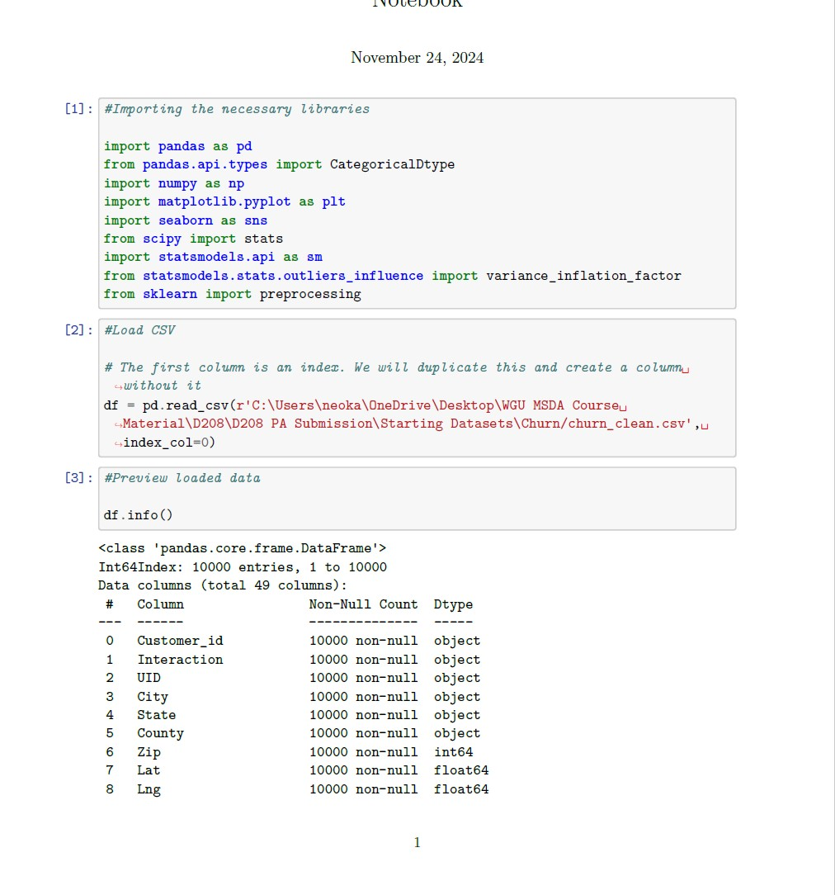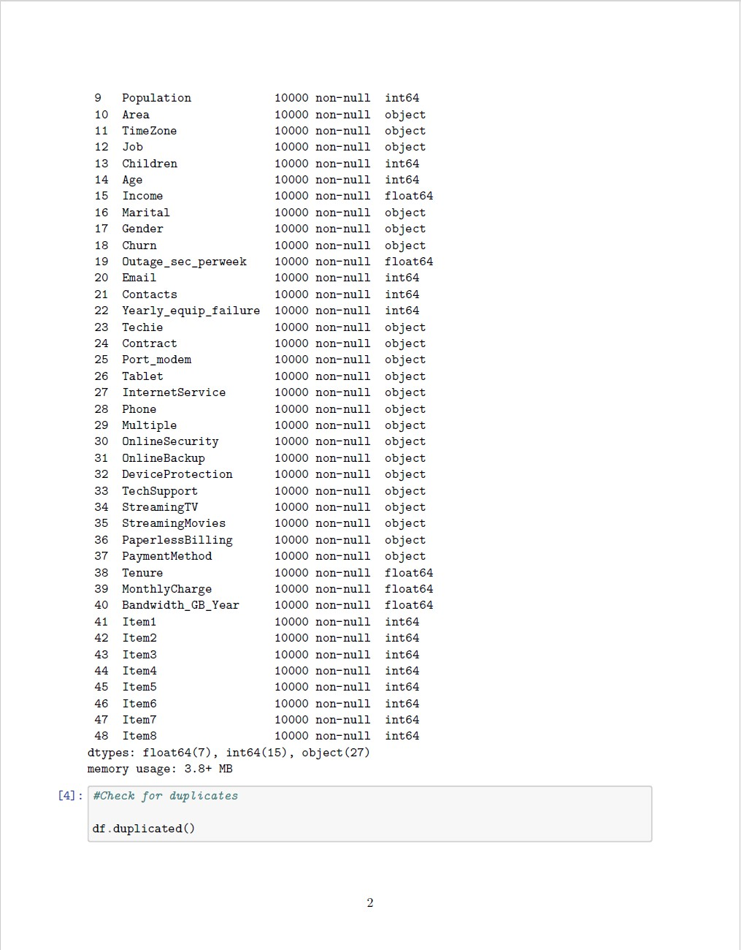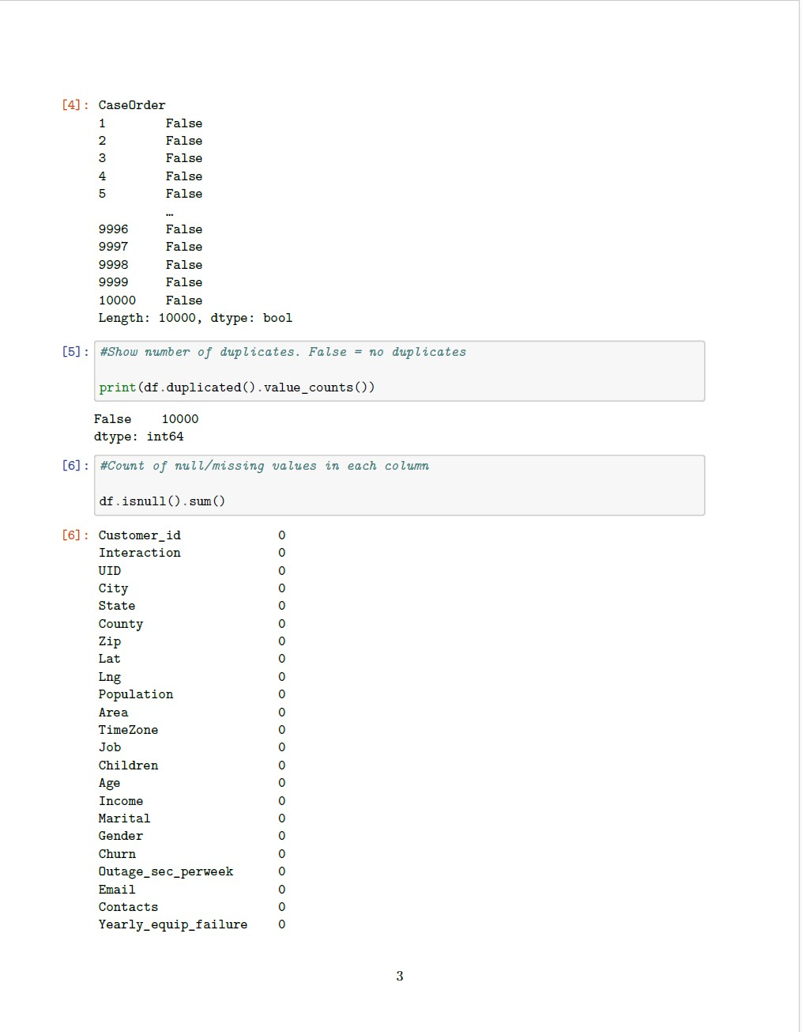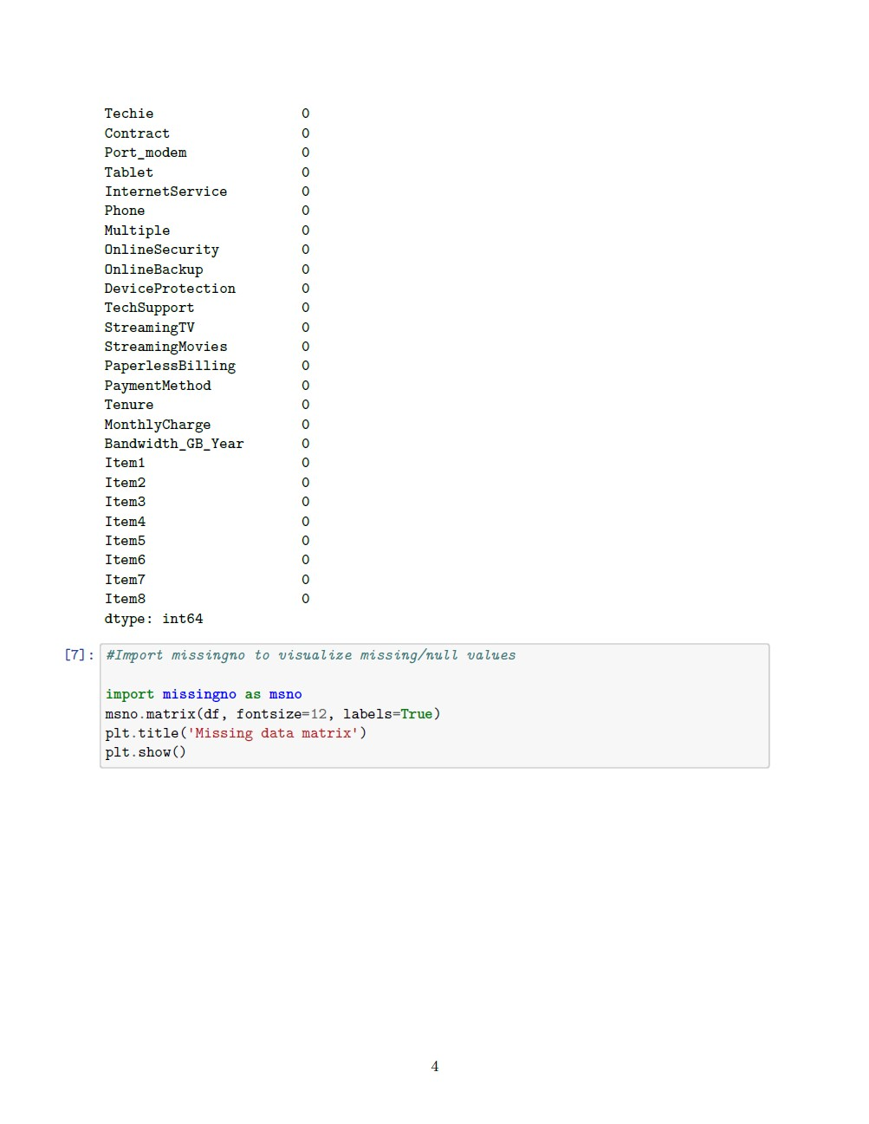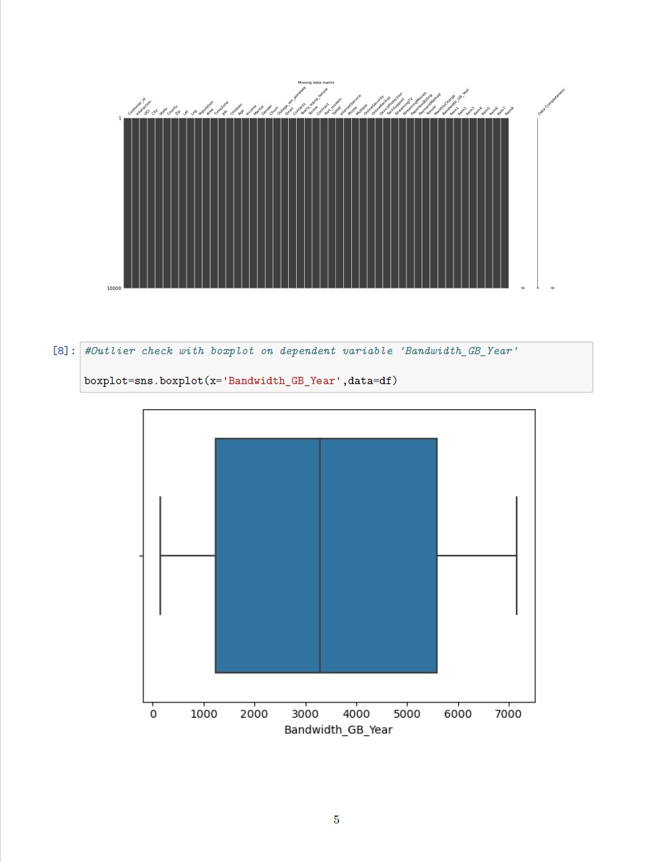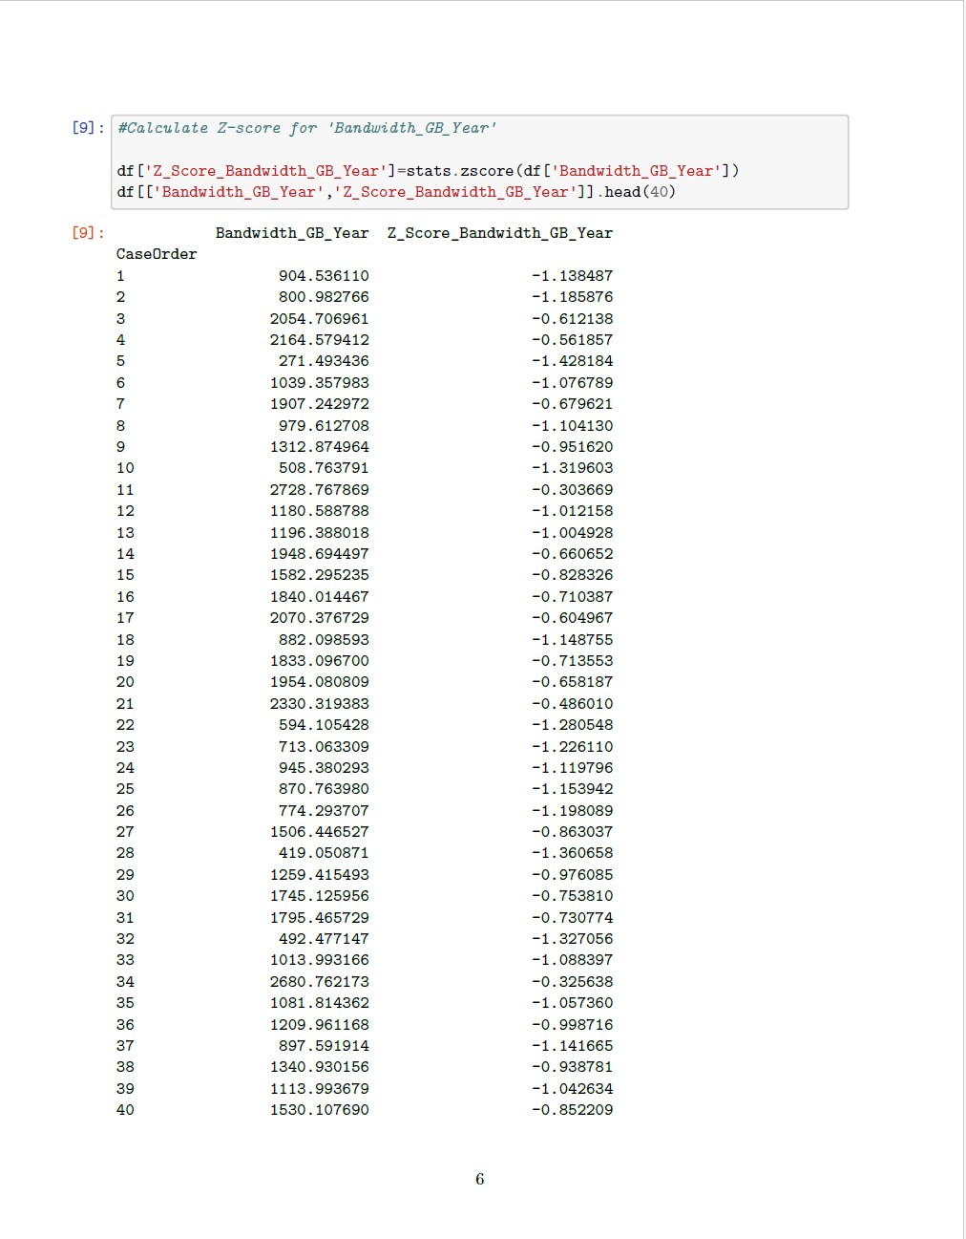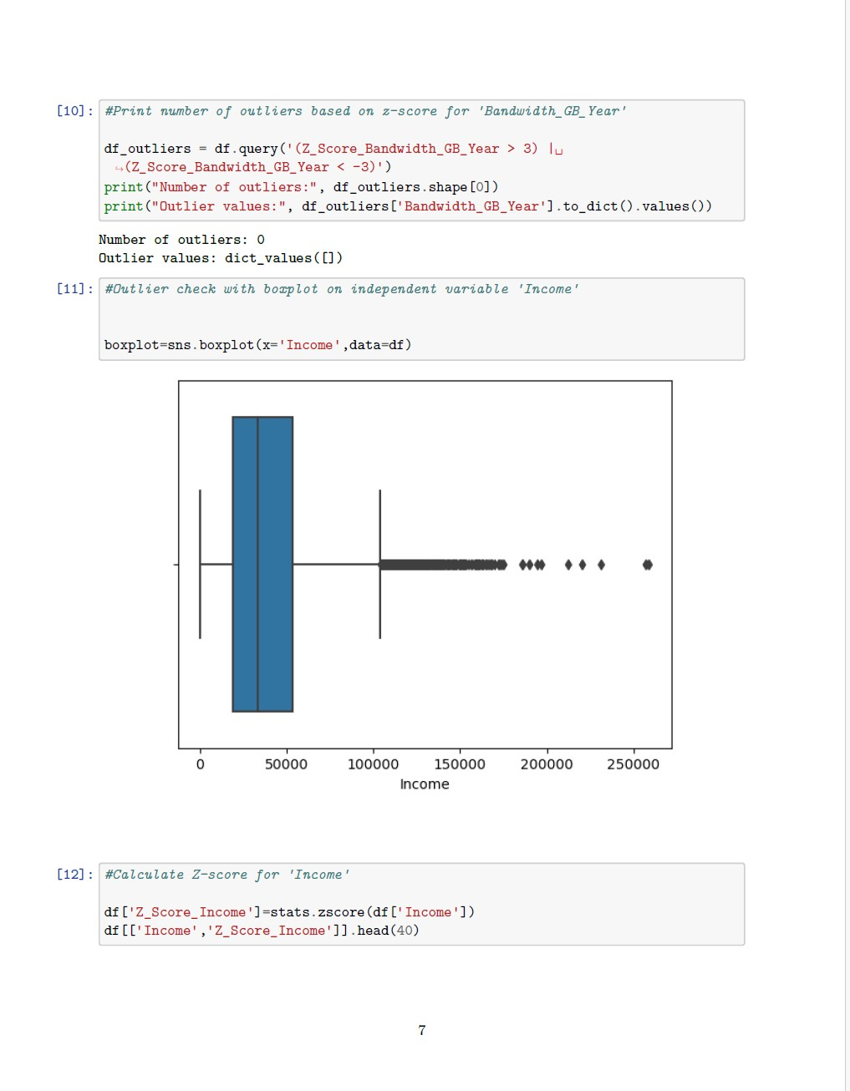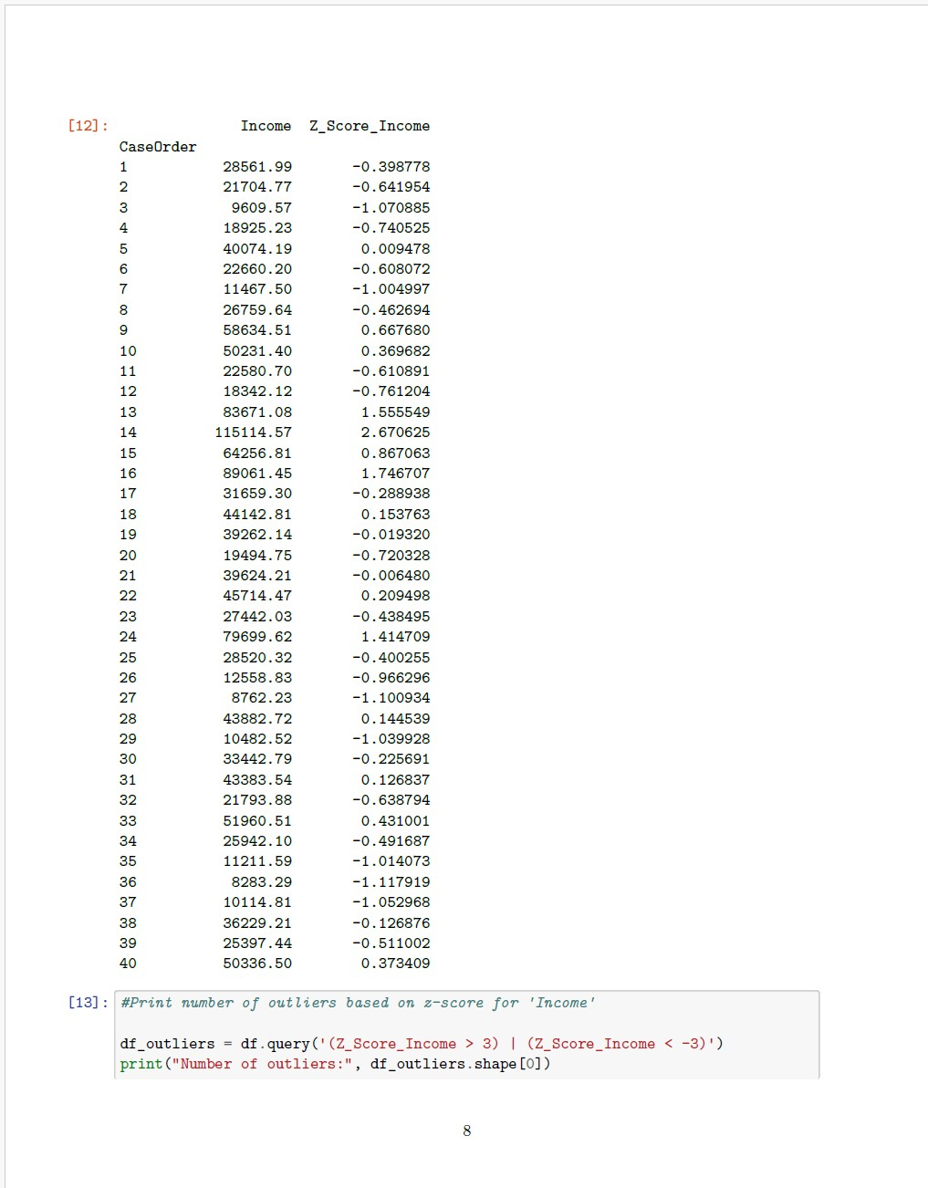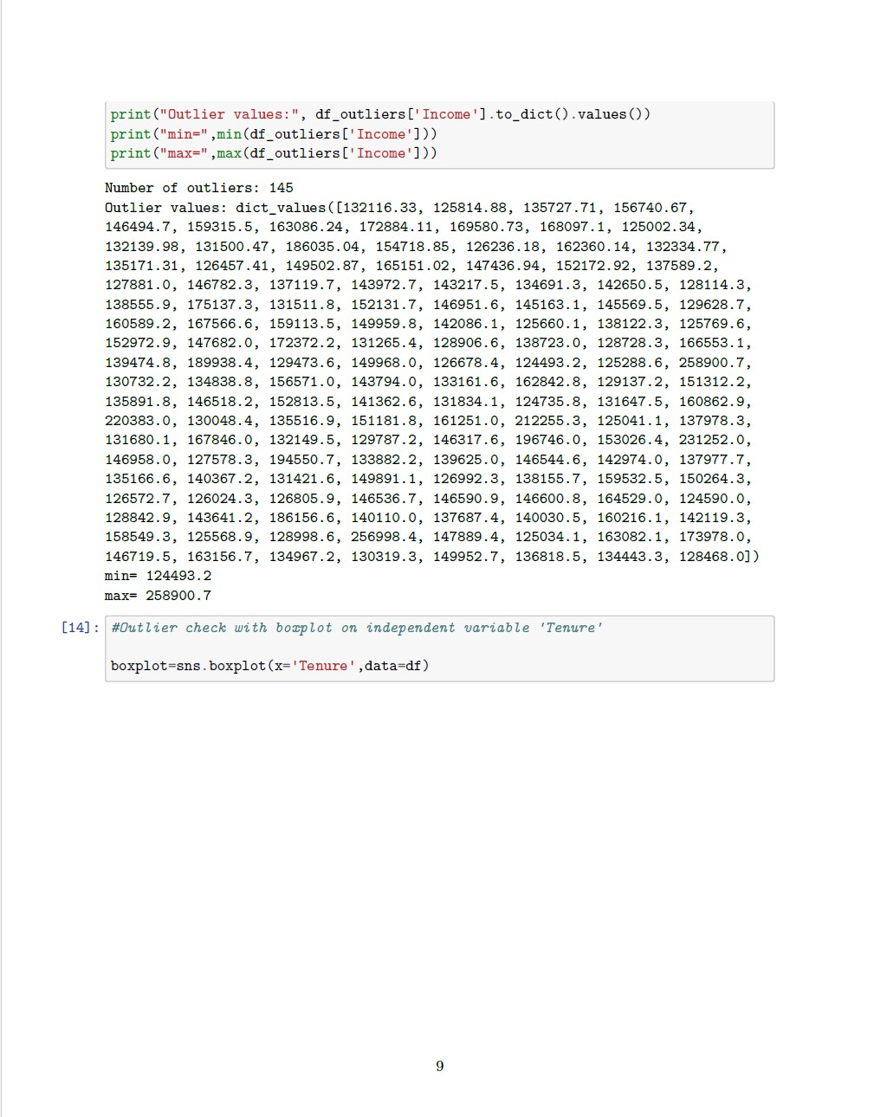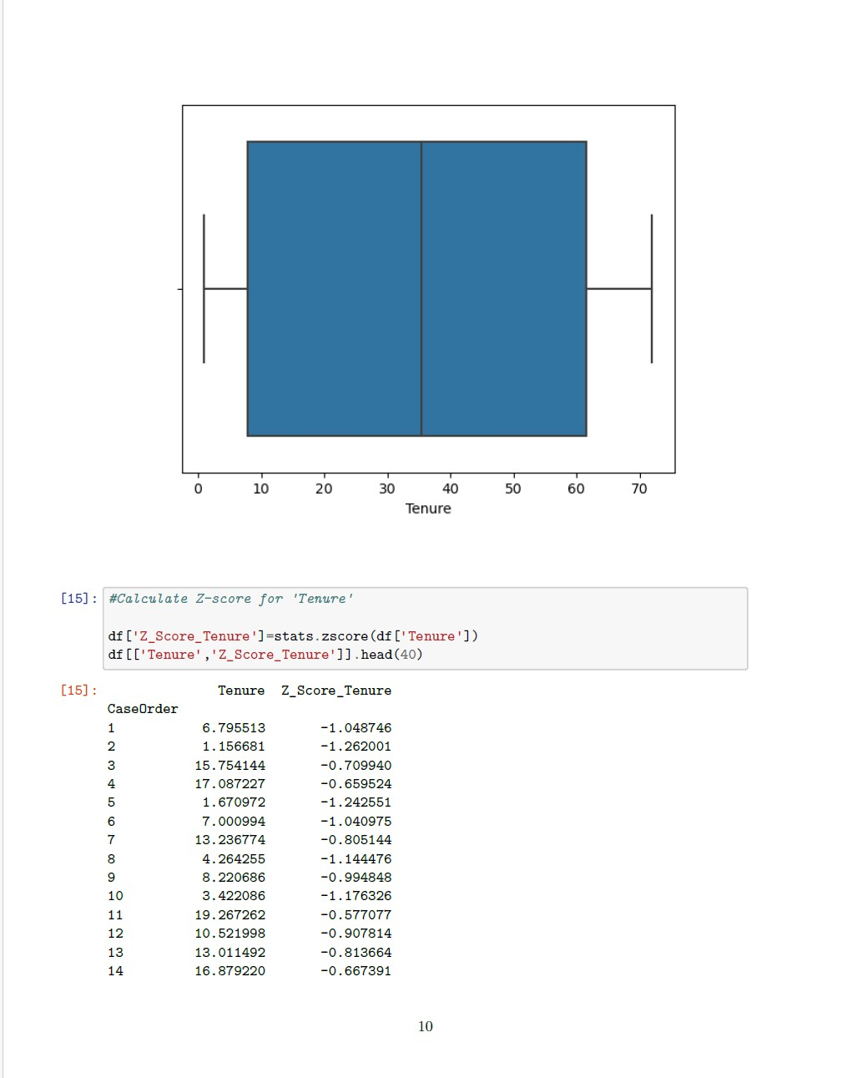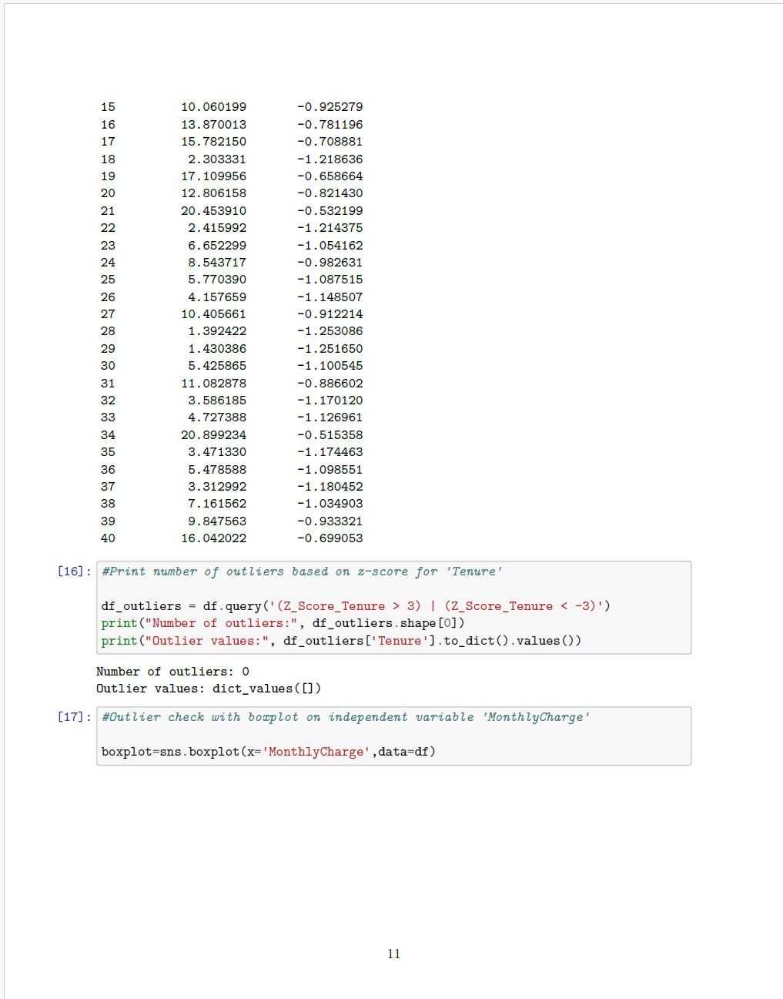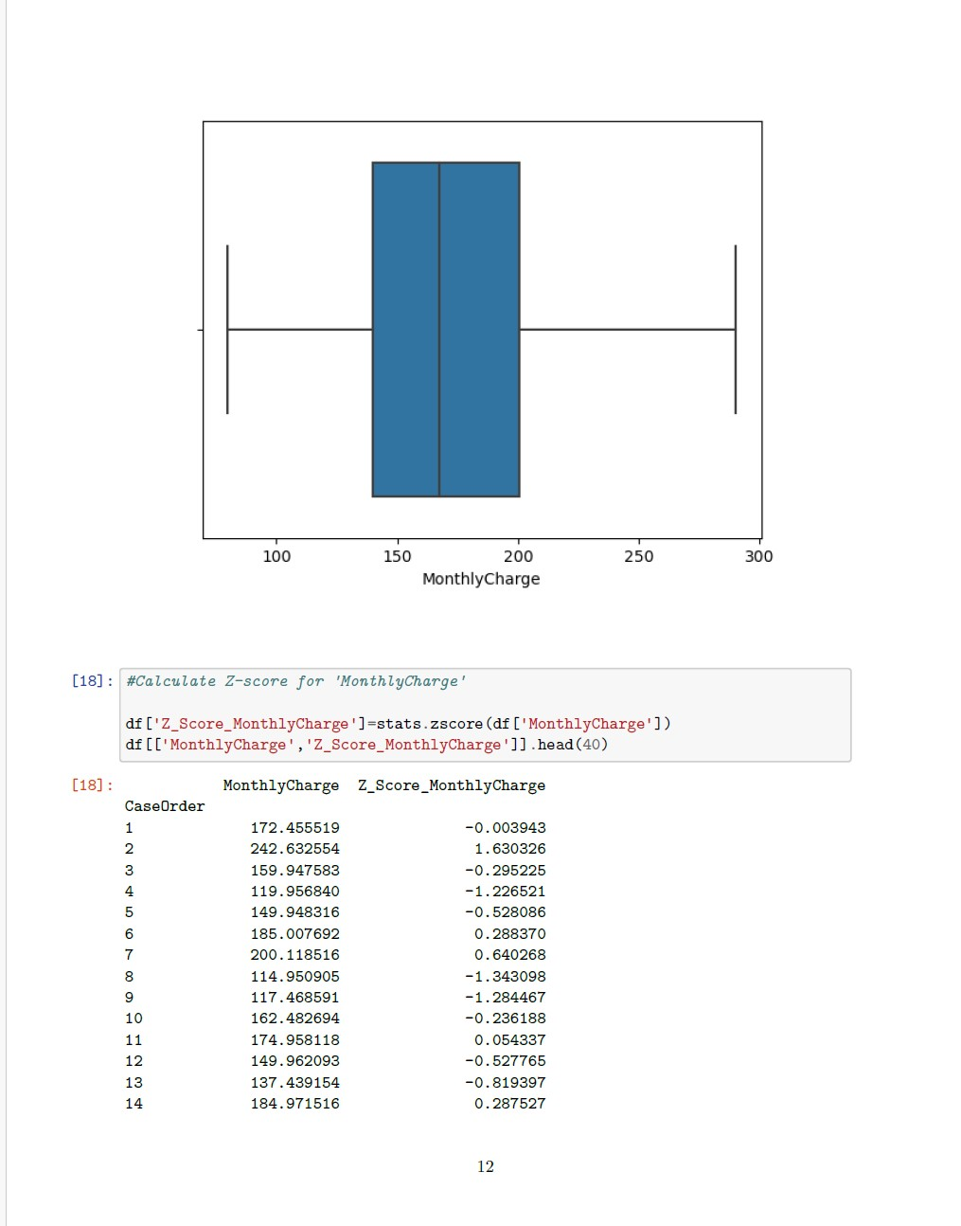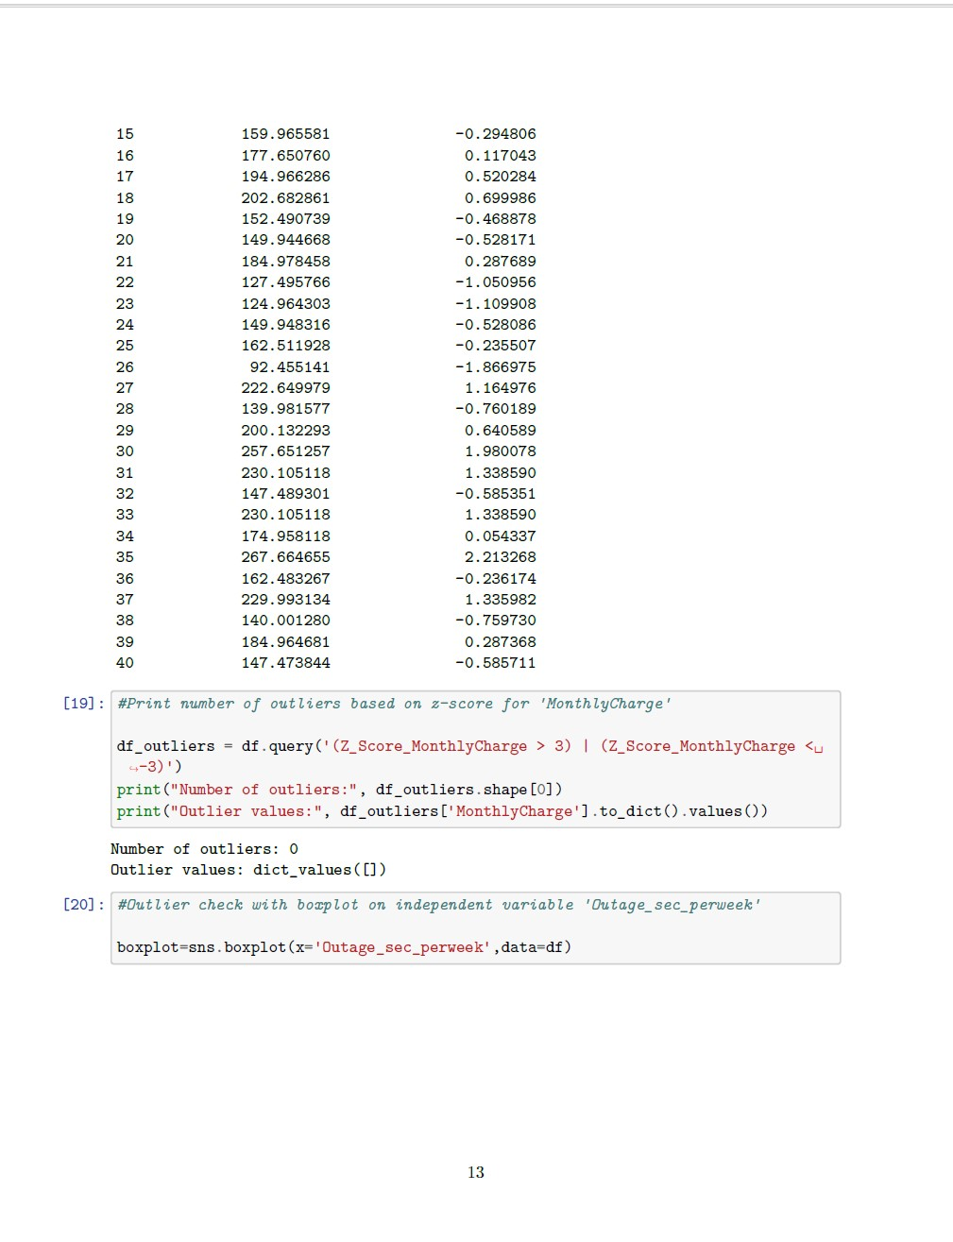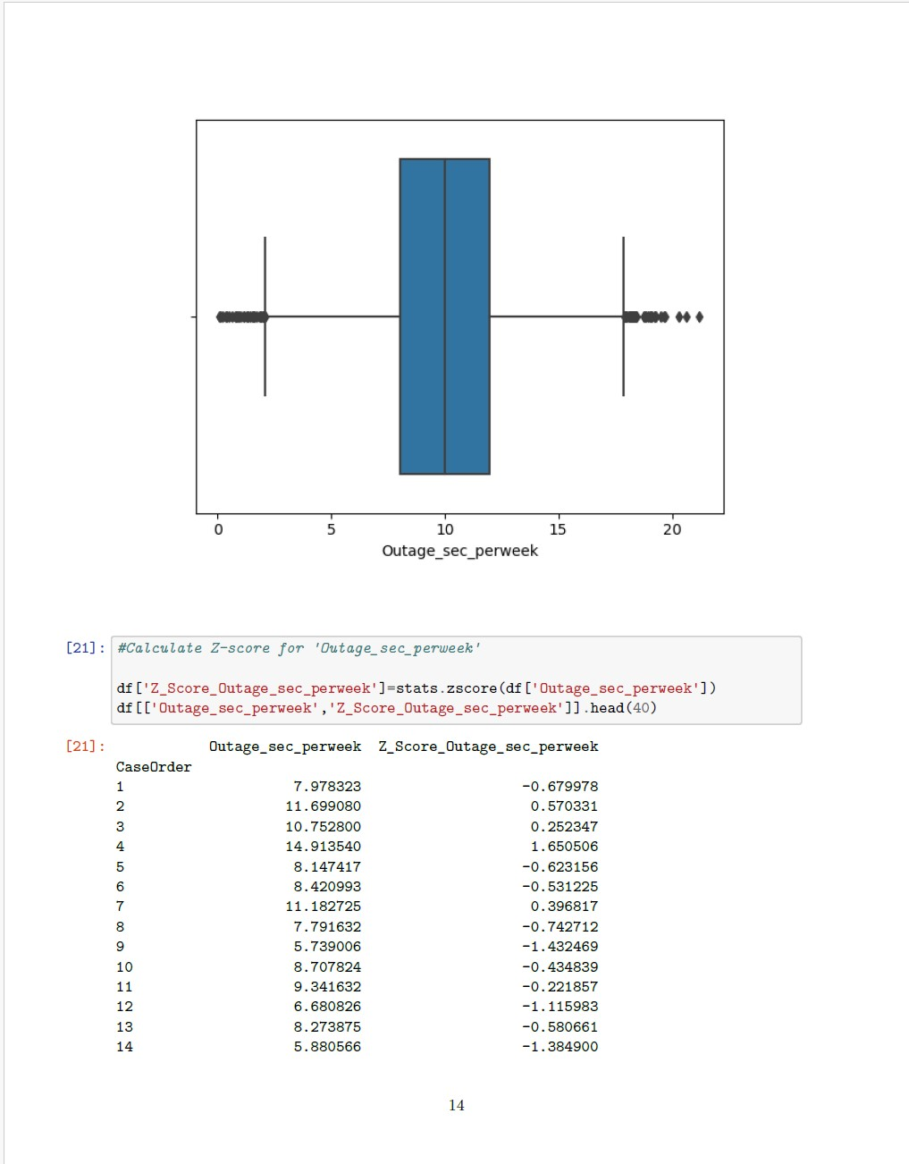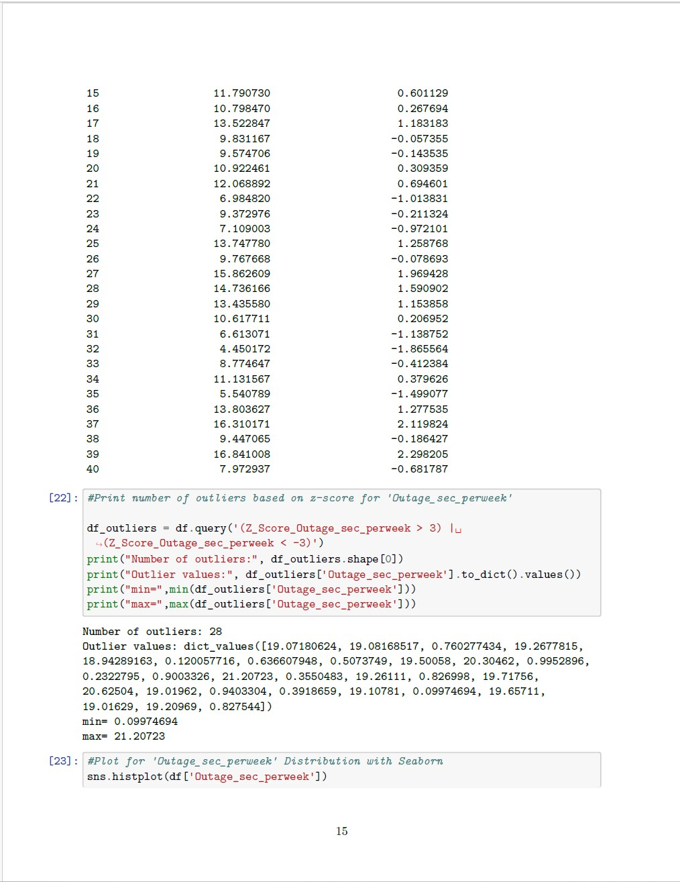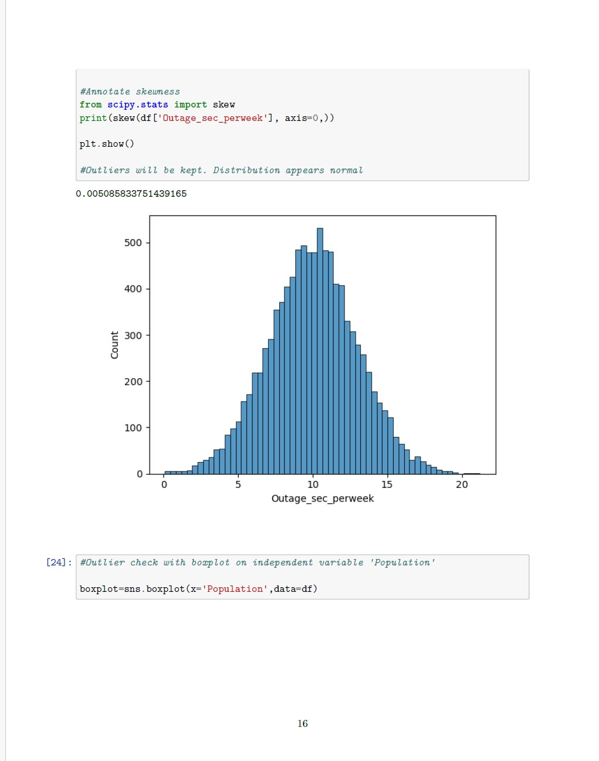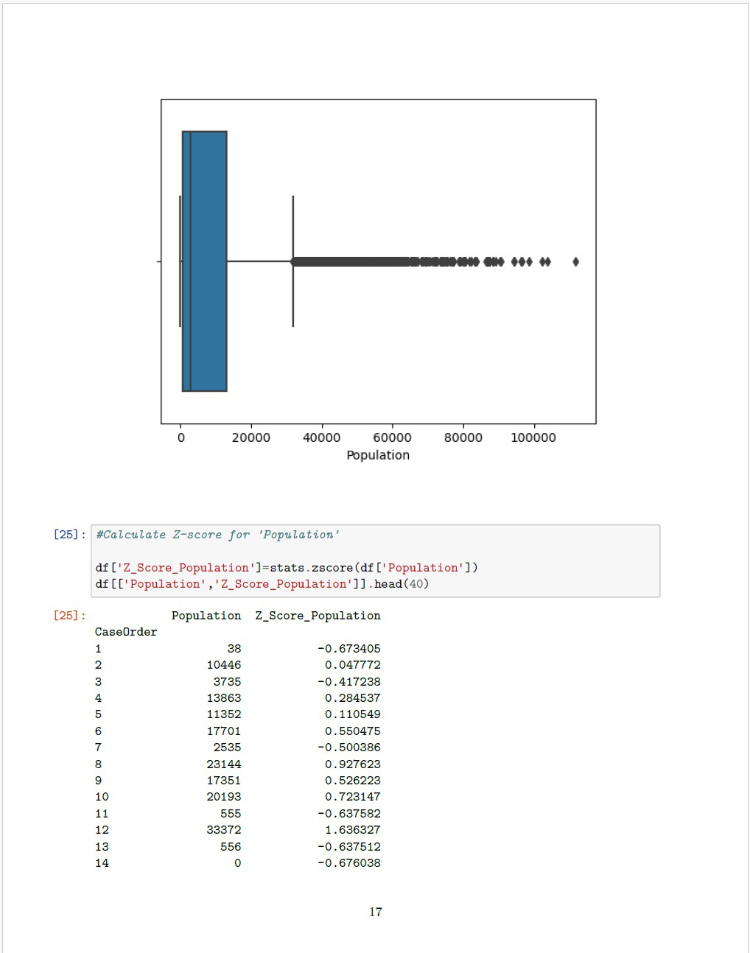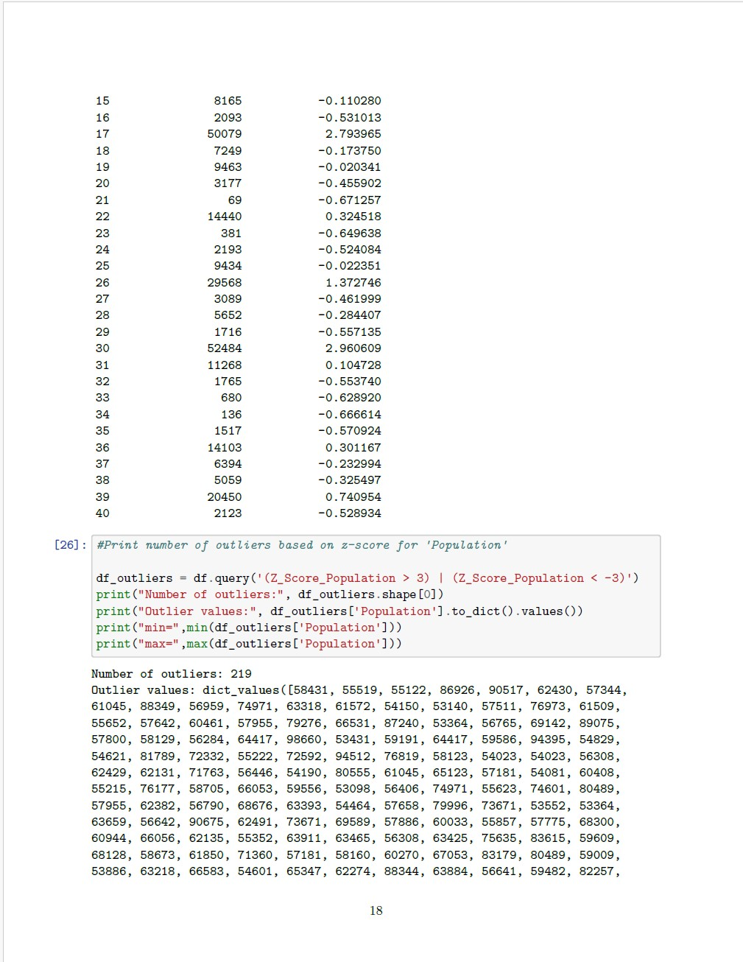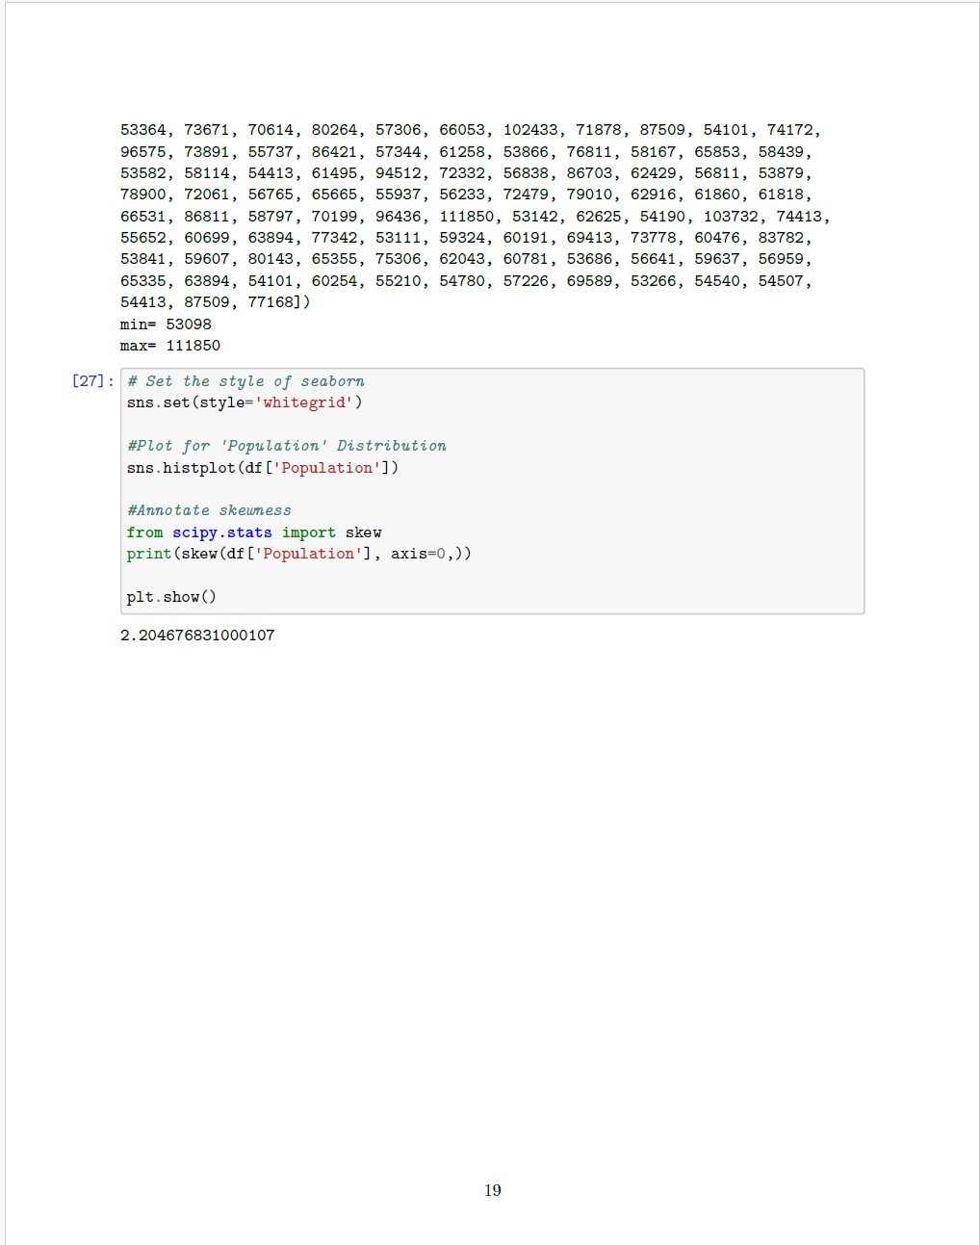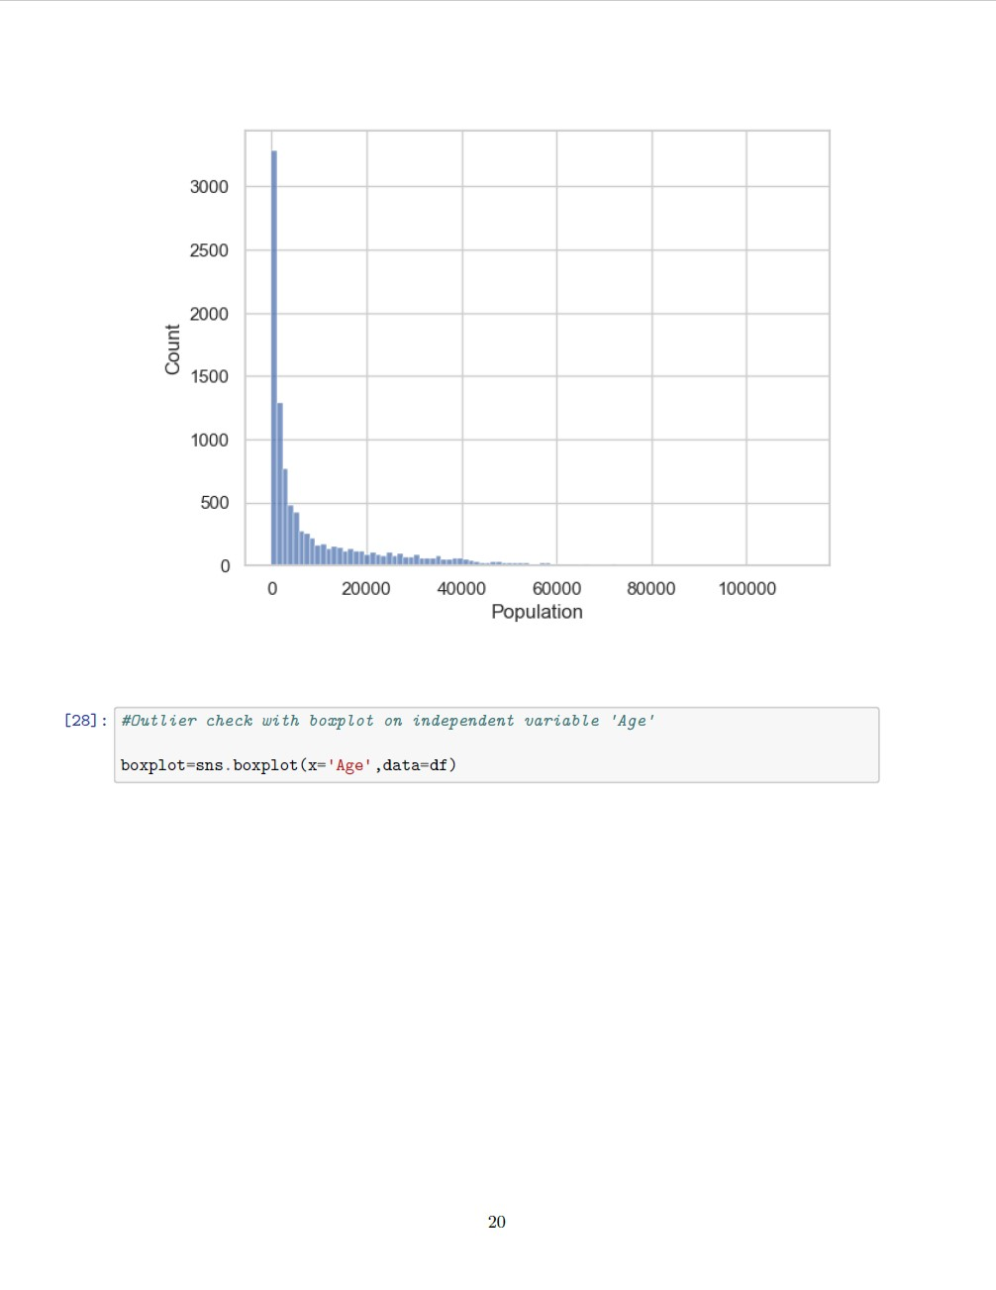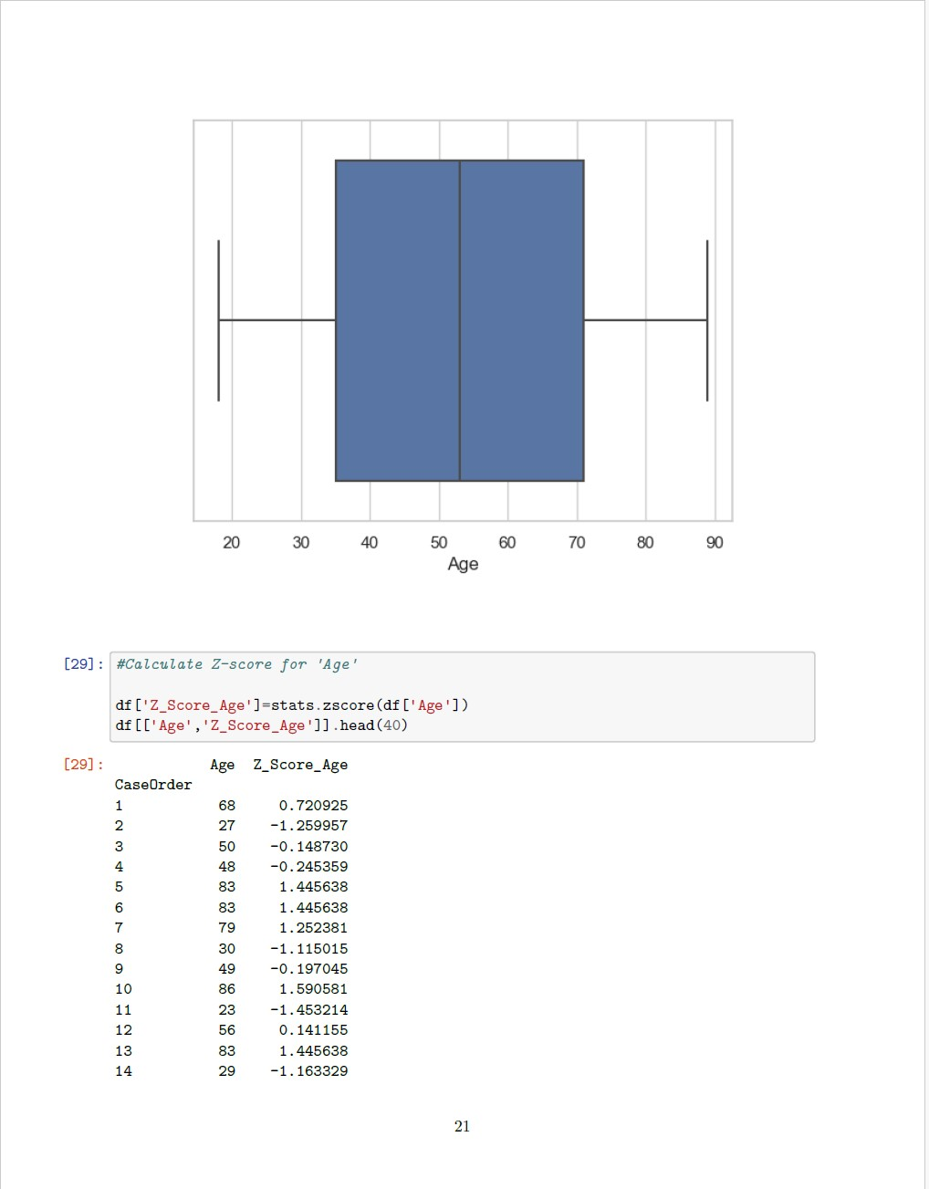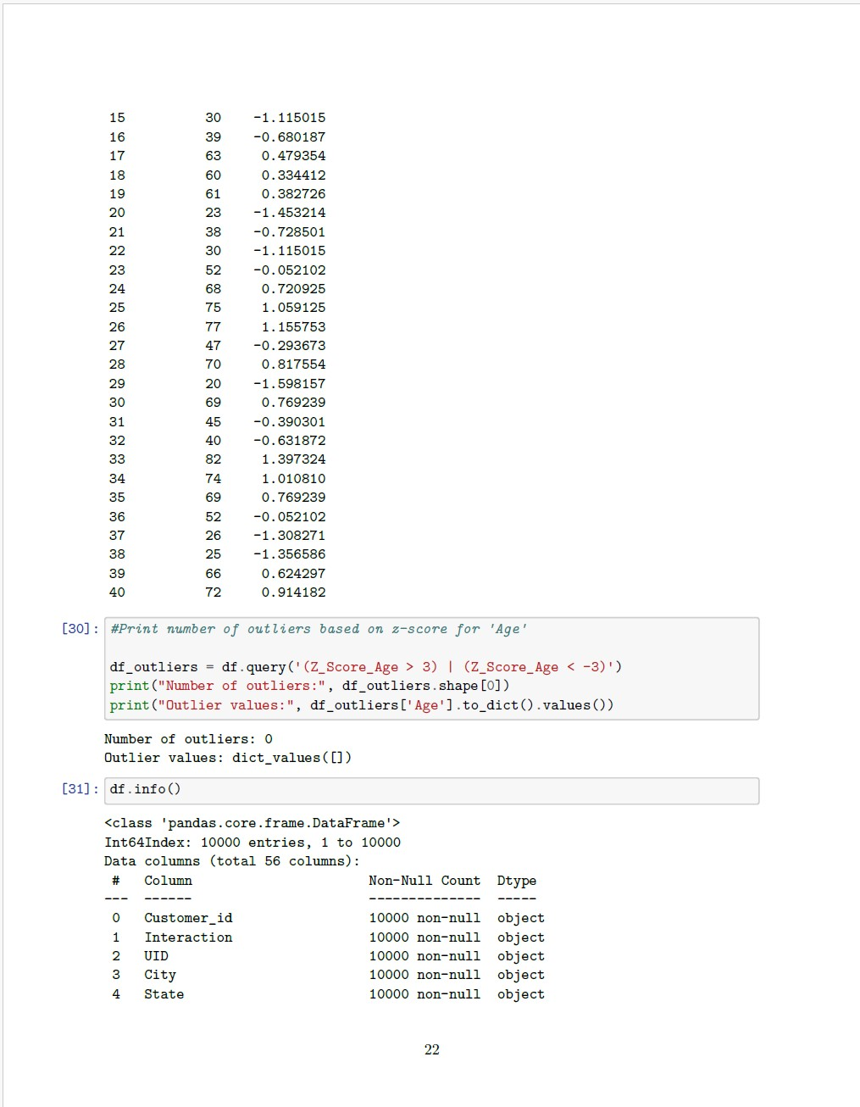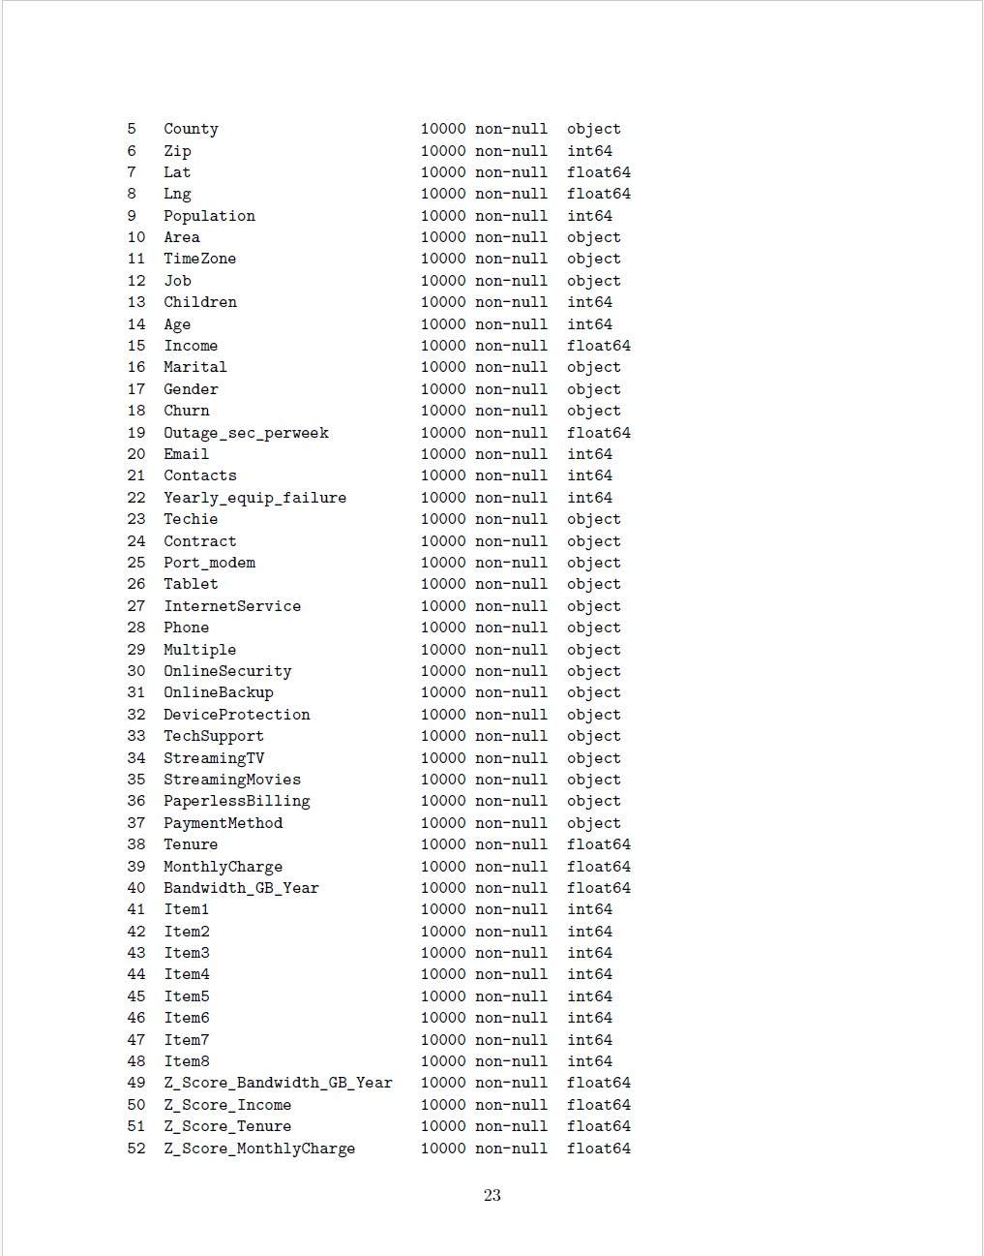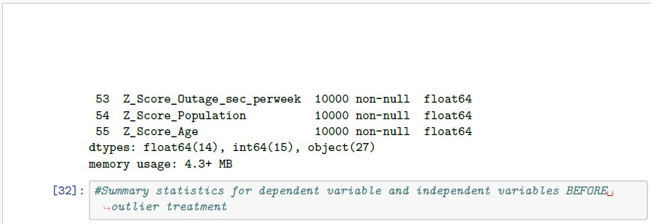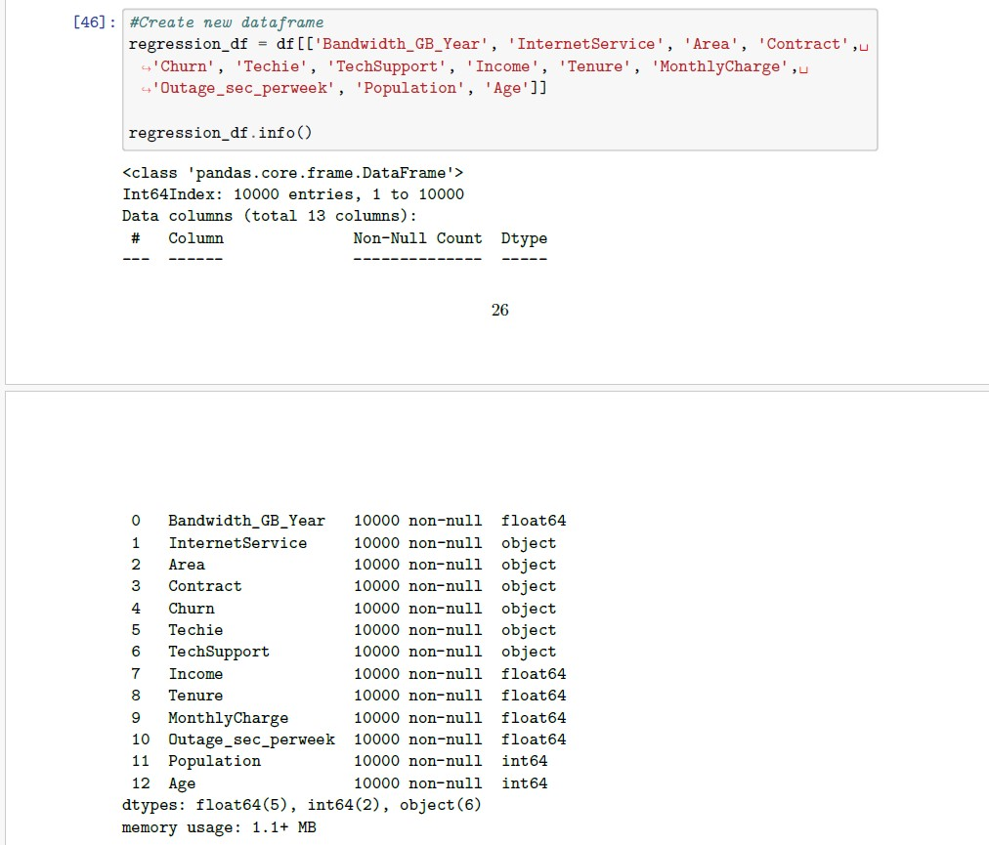

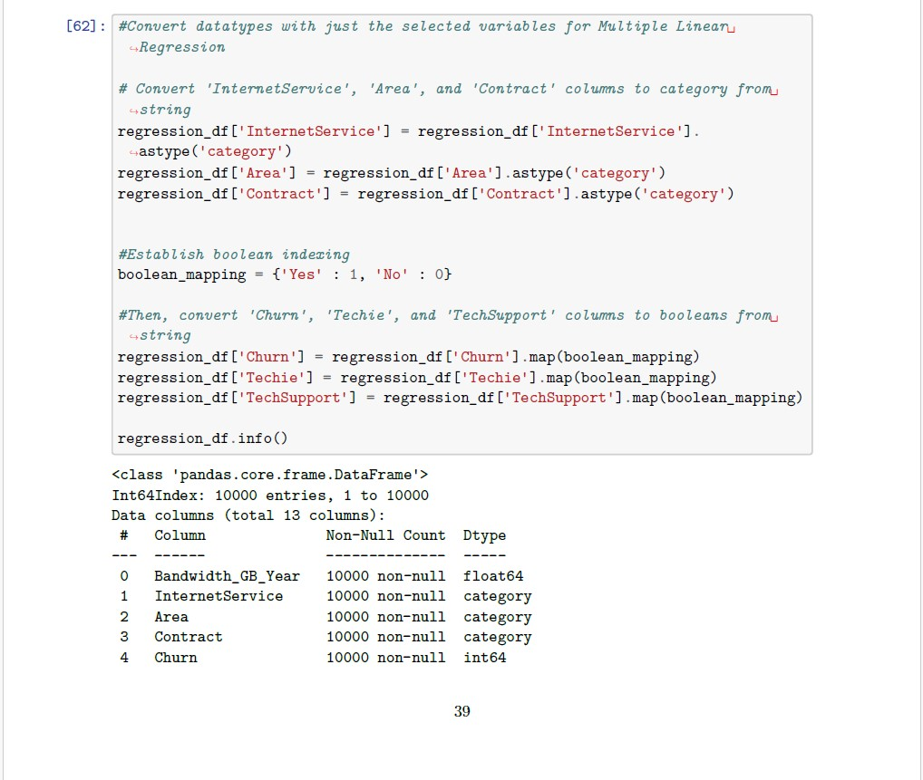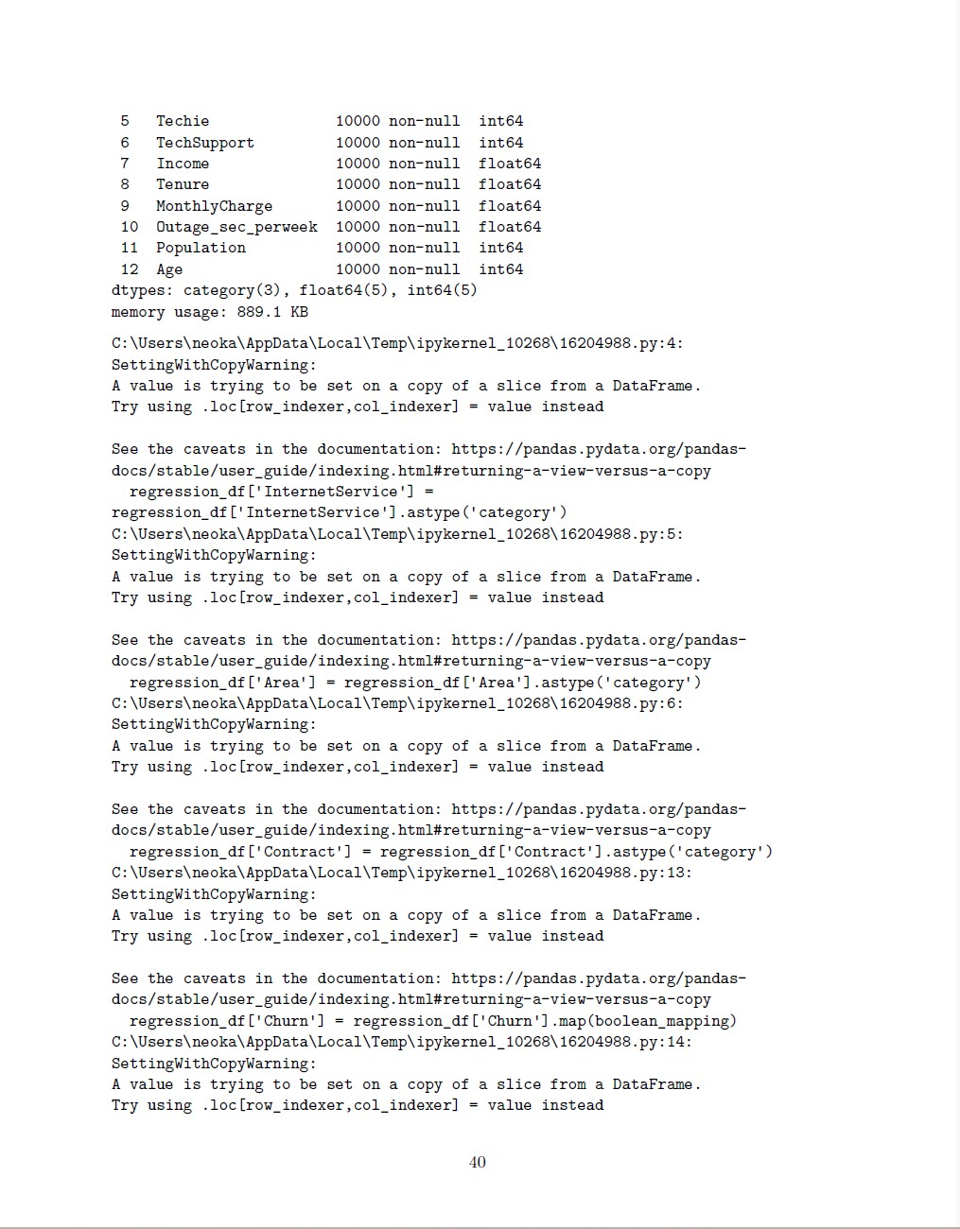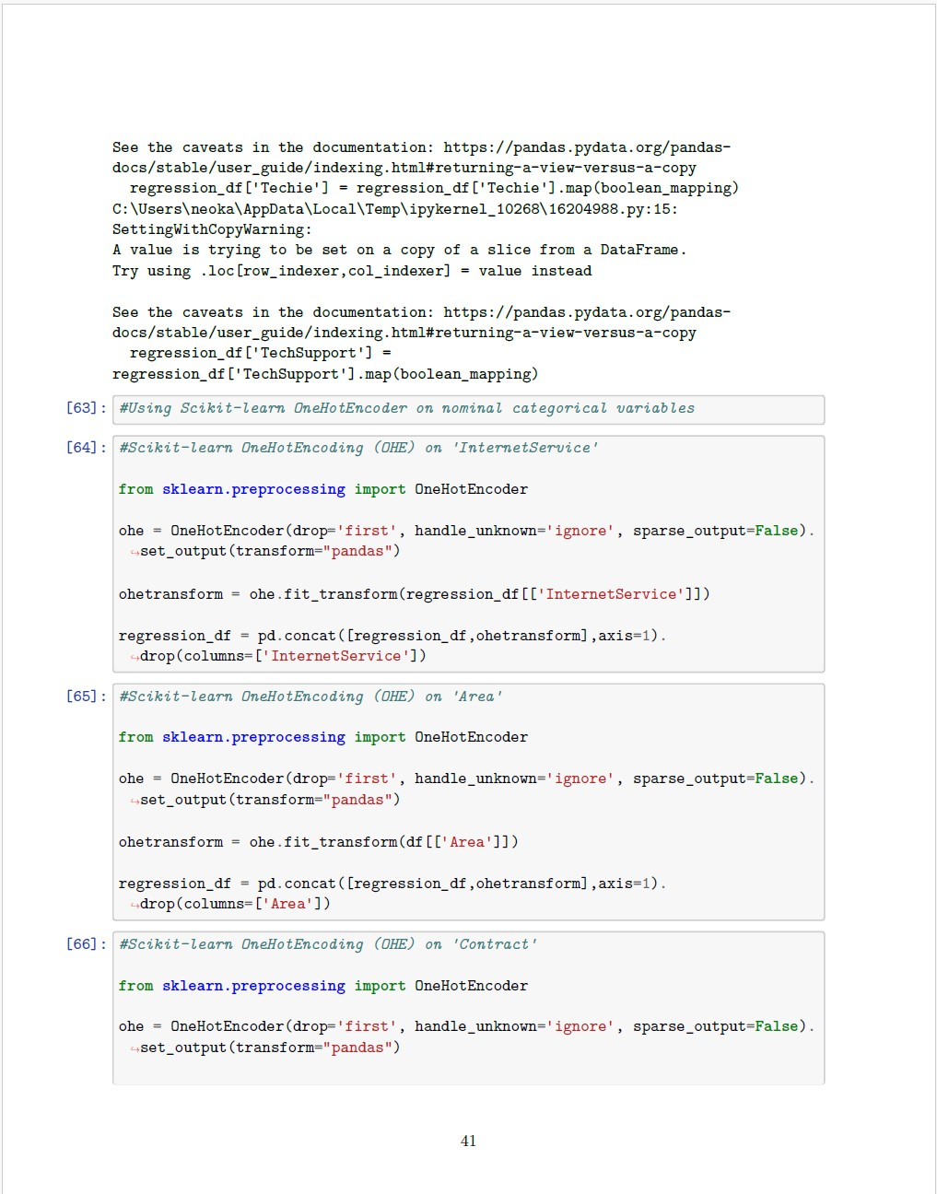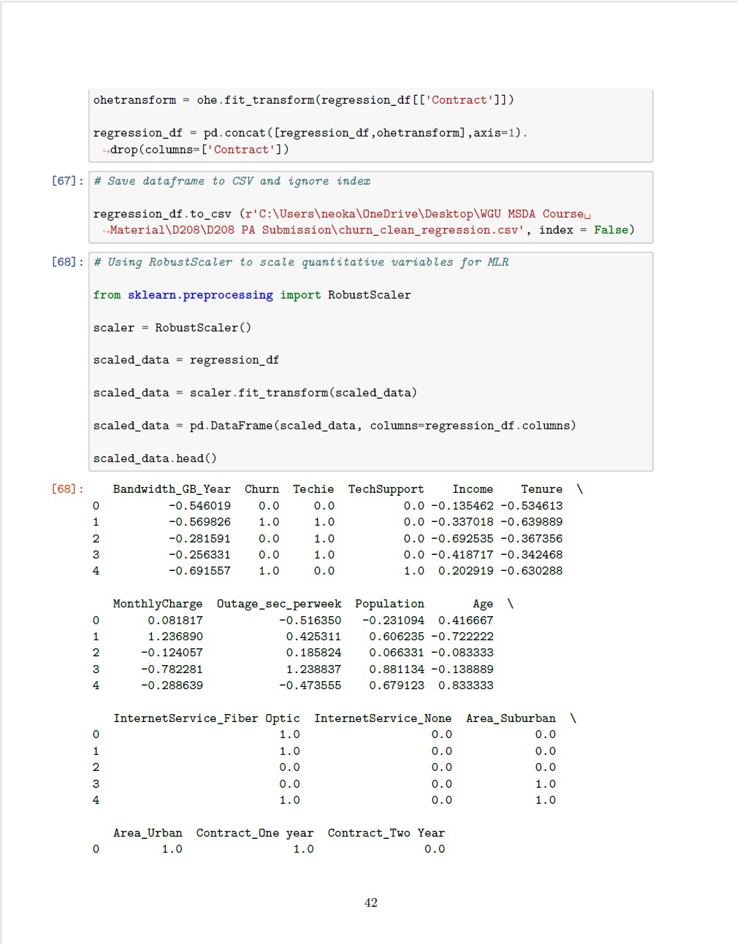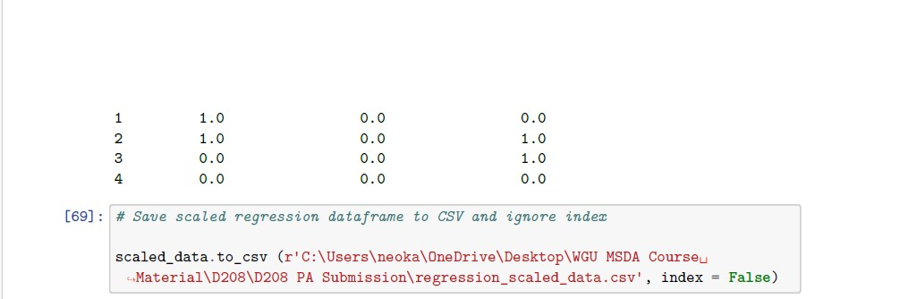

**C2: SUMMARY STATISTICS**

Each variable has 10,000 different samples with the following details per individual variable:

* Bandwidth_GB_Year has a mean value of about 3,392, a minimum of 155, and maximum of 7158
* Income has a mean of 39,806, a minimum of 348, and a maximum of 258,900
* Tenure has a mean of 34, a minimum of 1, and a maximum of approximately 72
* MonthlyCharge has a mean of 172, a minimum of 79, and a maximum of 290
* Outage_sec_perweek has a mean of 10, minimum of about 0.099, and a maximum of 21
* Population has a mean of 9,756, a minimum of 0 and a maximum of 111,850
* Age has a mean of 53, a minimum of 18, and a maximum of 89
* InternetService has the following customer breakdown counts for the following categories: Fiber Optic - 4,408; DSL - 3,463; None (No Internet Service) – 2,129
* Area has the following customer breakdown counts for the following categories: Suburban - 3,346; Urban - 3,327; Rural – 3,327
* Contract has the following customer breakdown counts for the following categories: Month-to-month – 5,456; Two Year - 2,442; One year – 2,102
* Churn has the following customer breakdown counts for the following categories: No – 7,350; Yes – 2,650
* Techie has the following customer breakdown counts for the following categories: No – 8,321; Yes – 1,679
* TechSupport has the following customer breakdown counts for the following categories: No – 6,250; Yes – 3,750

The following code shows summary statistics for the 13 total variables I have chosen for the initial MLR:

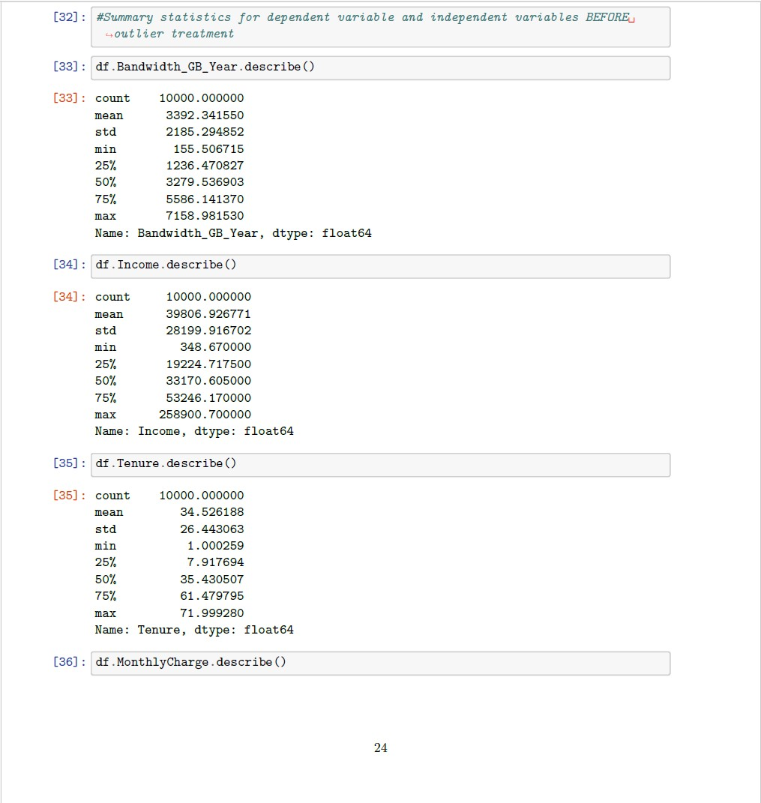

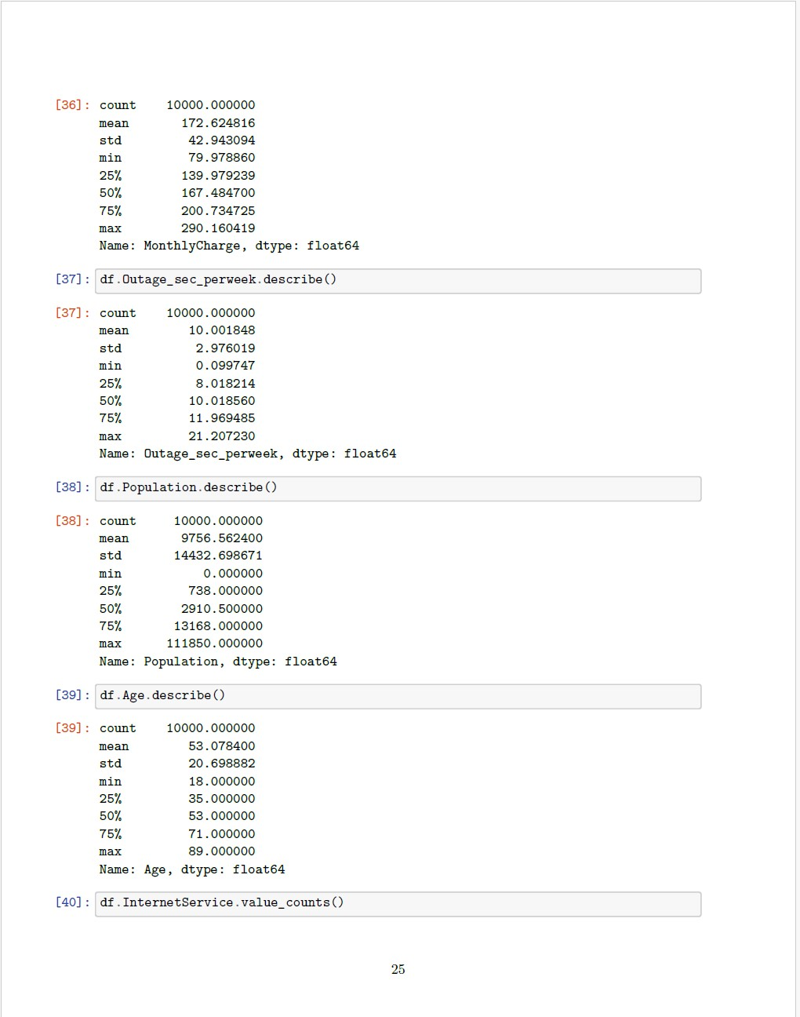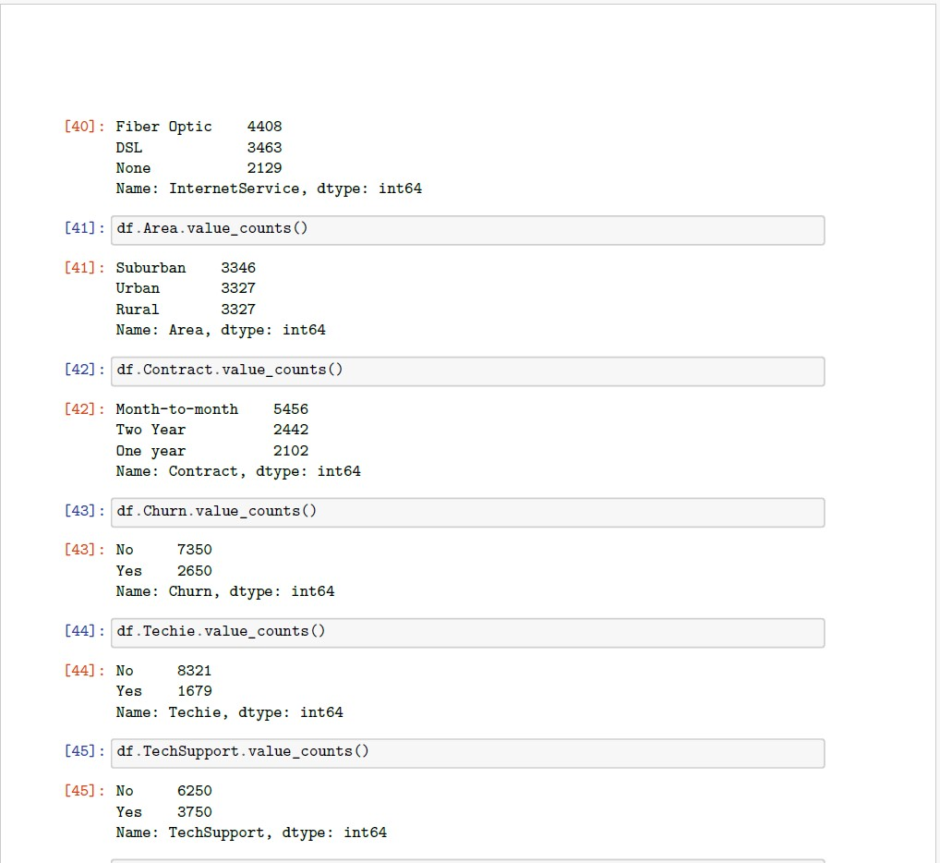

**C3: VISUALIZATIONS**

The following code and graphs display univariate and bivariate graphs for the dependent variable and independent variables. 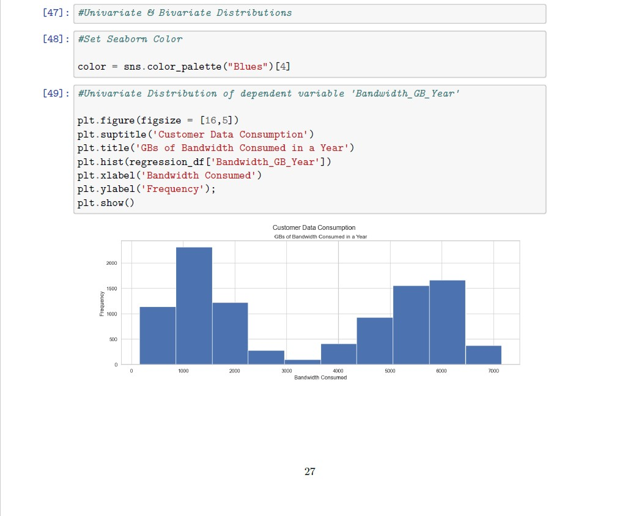

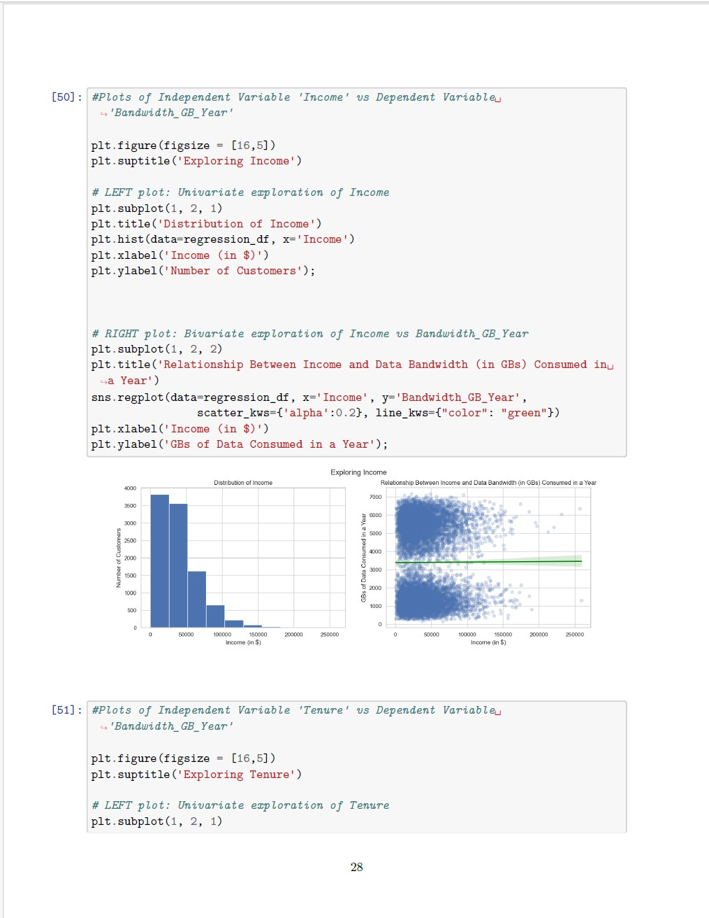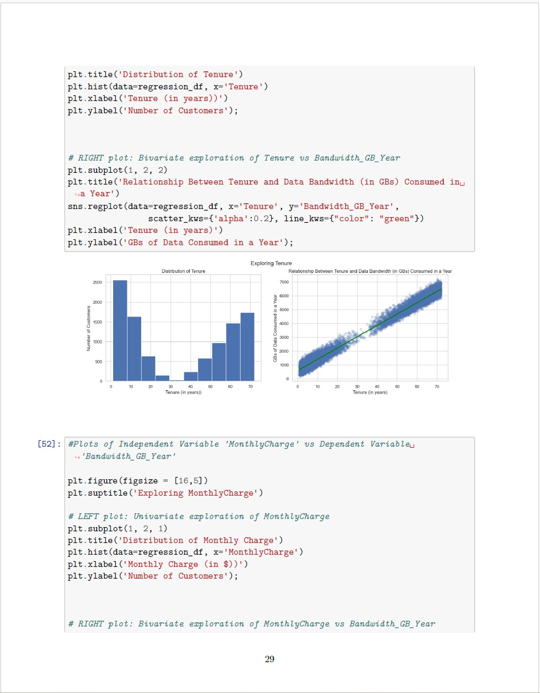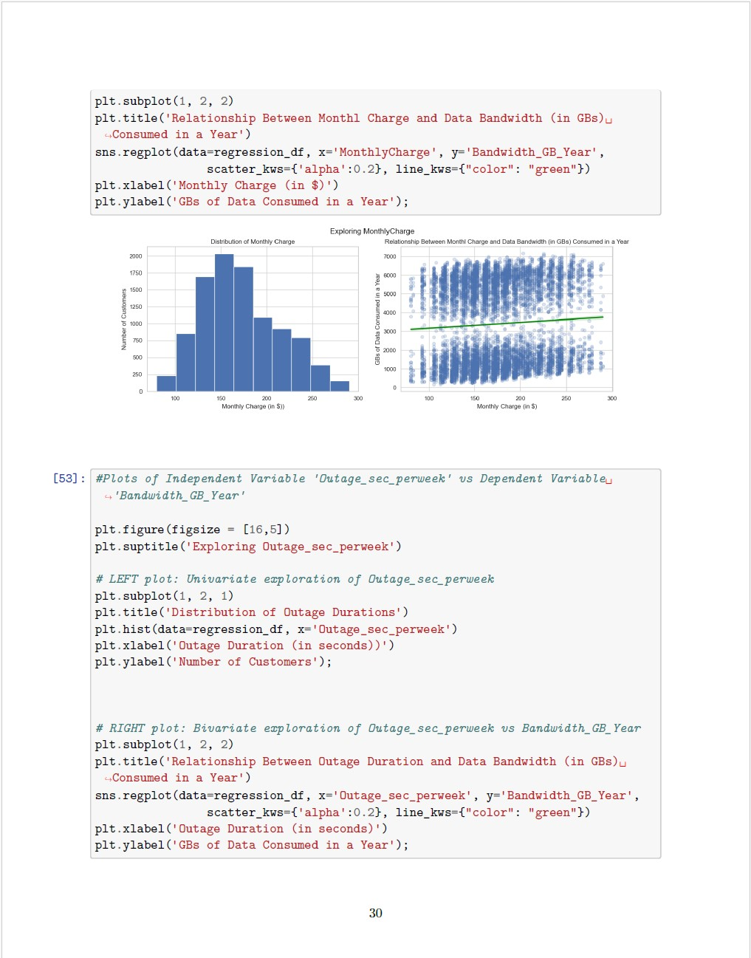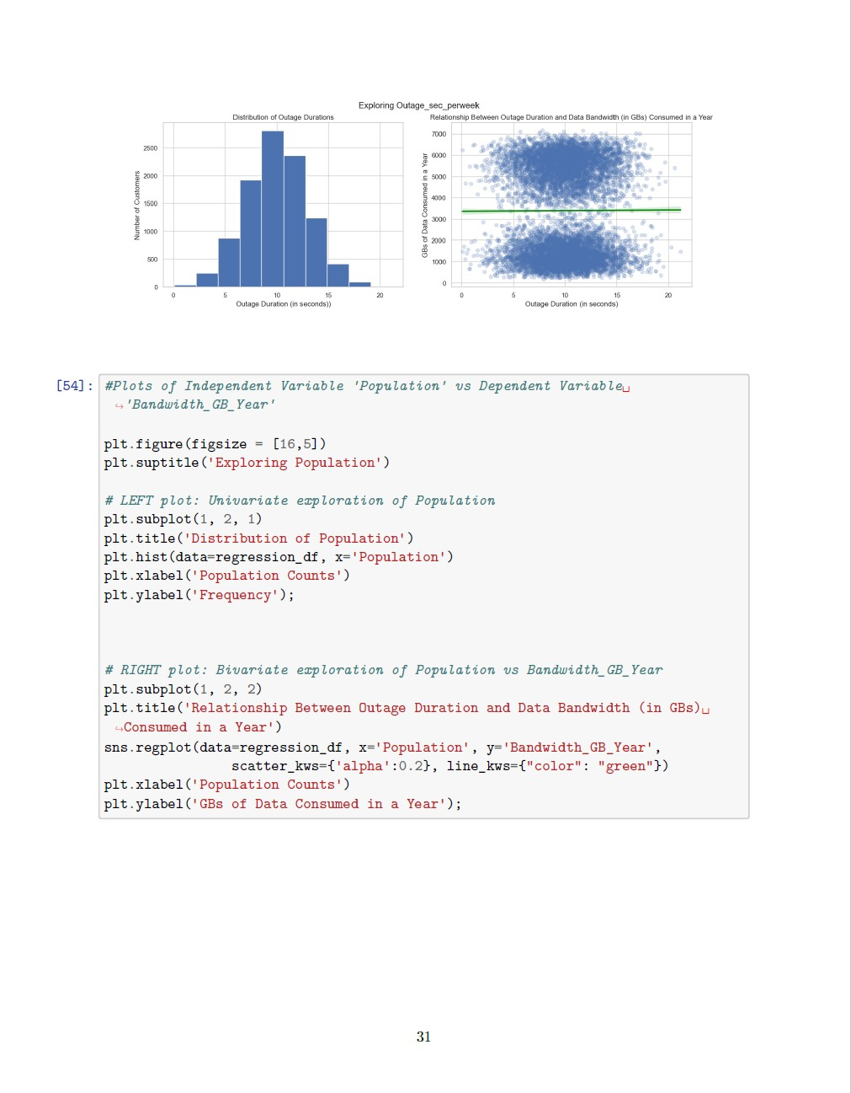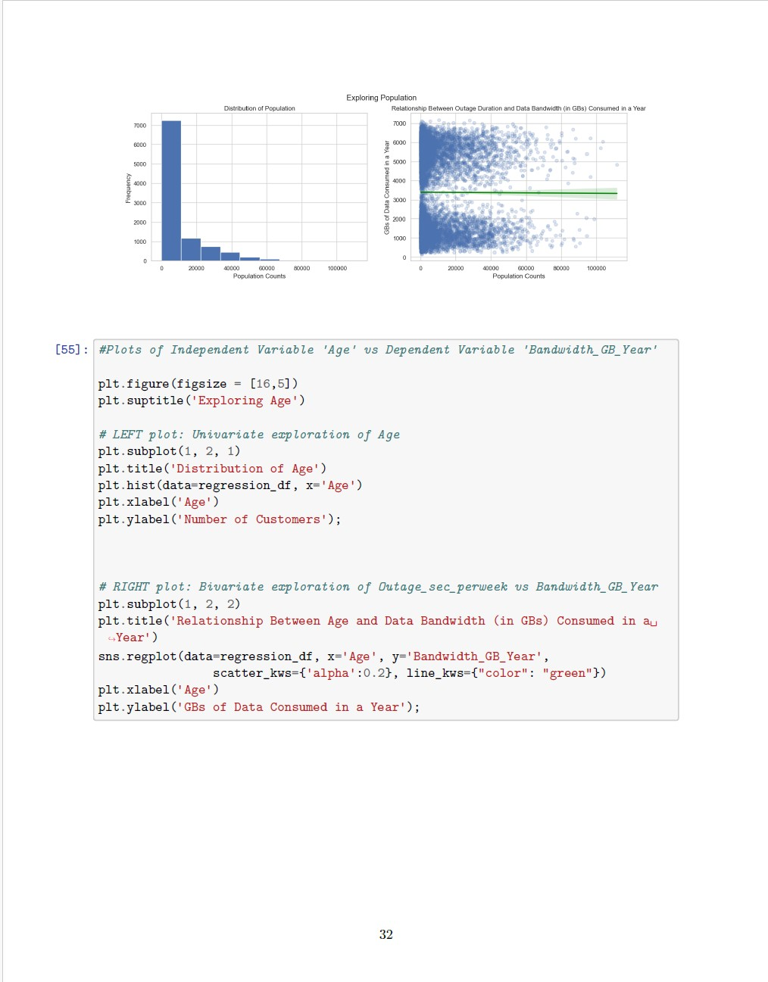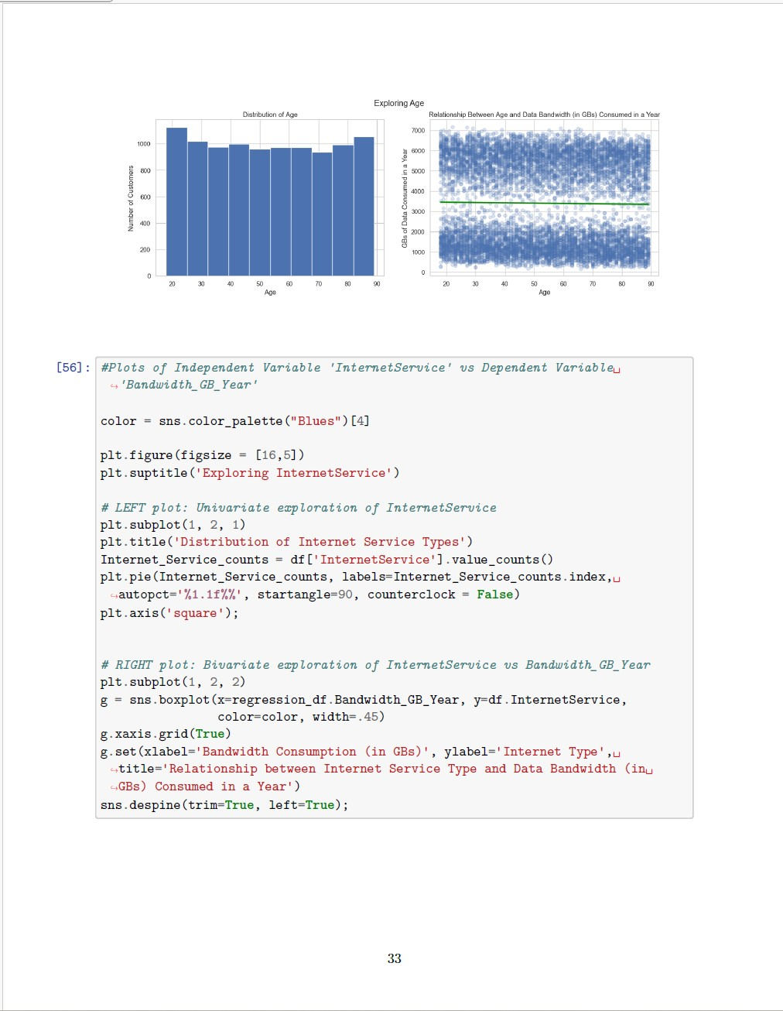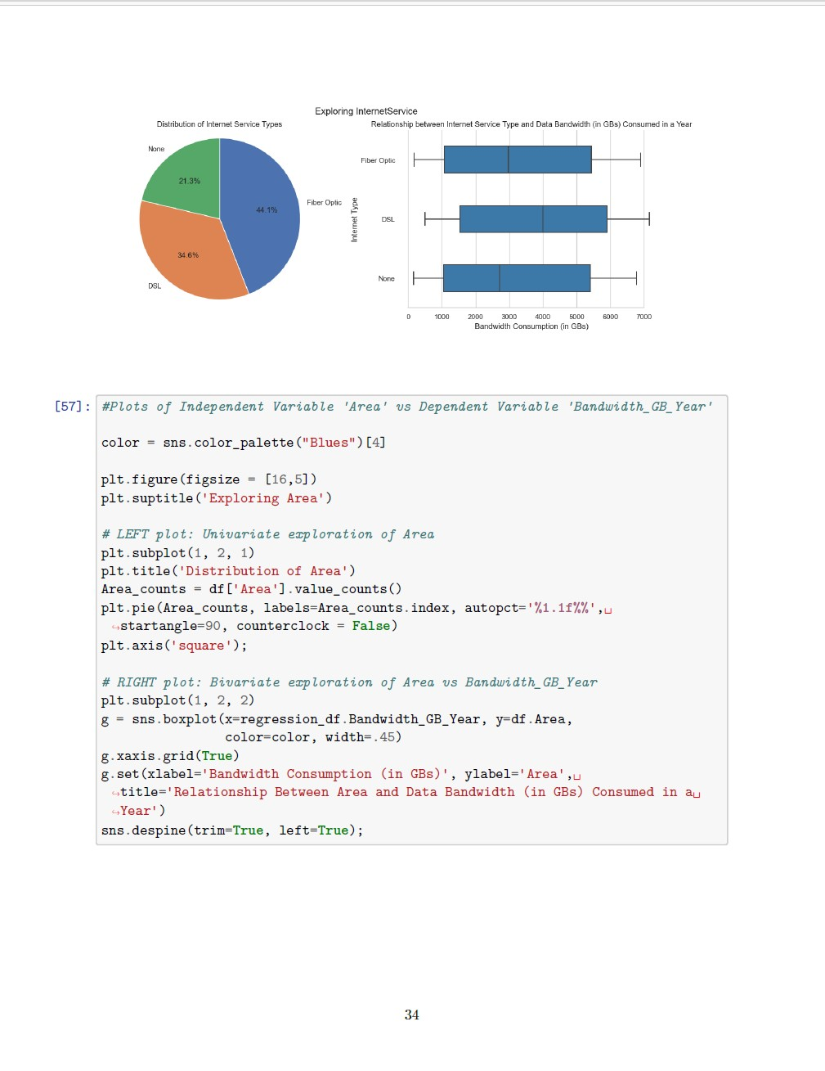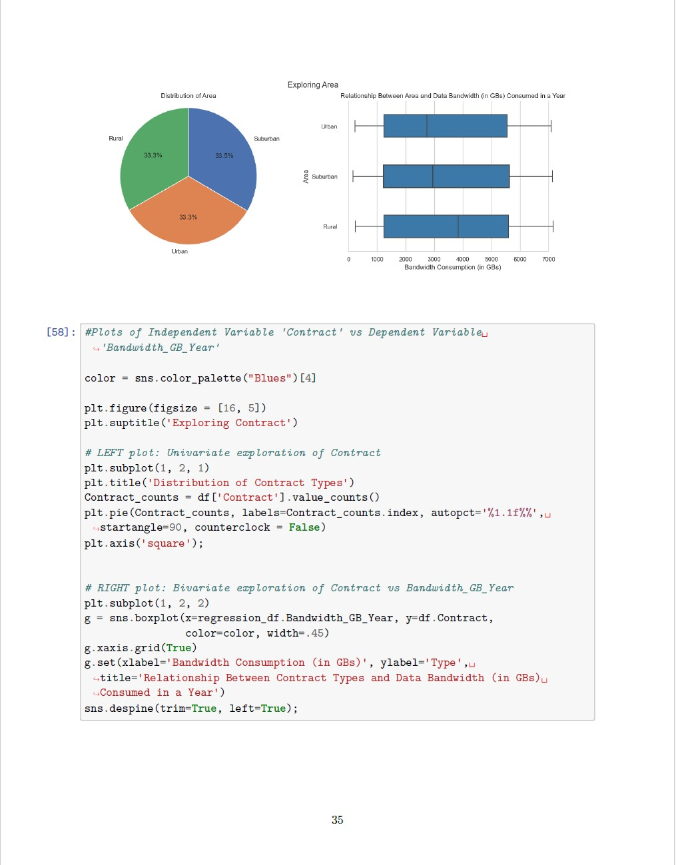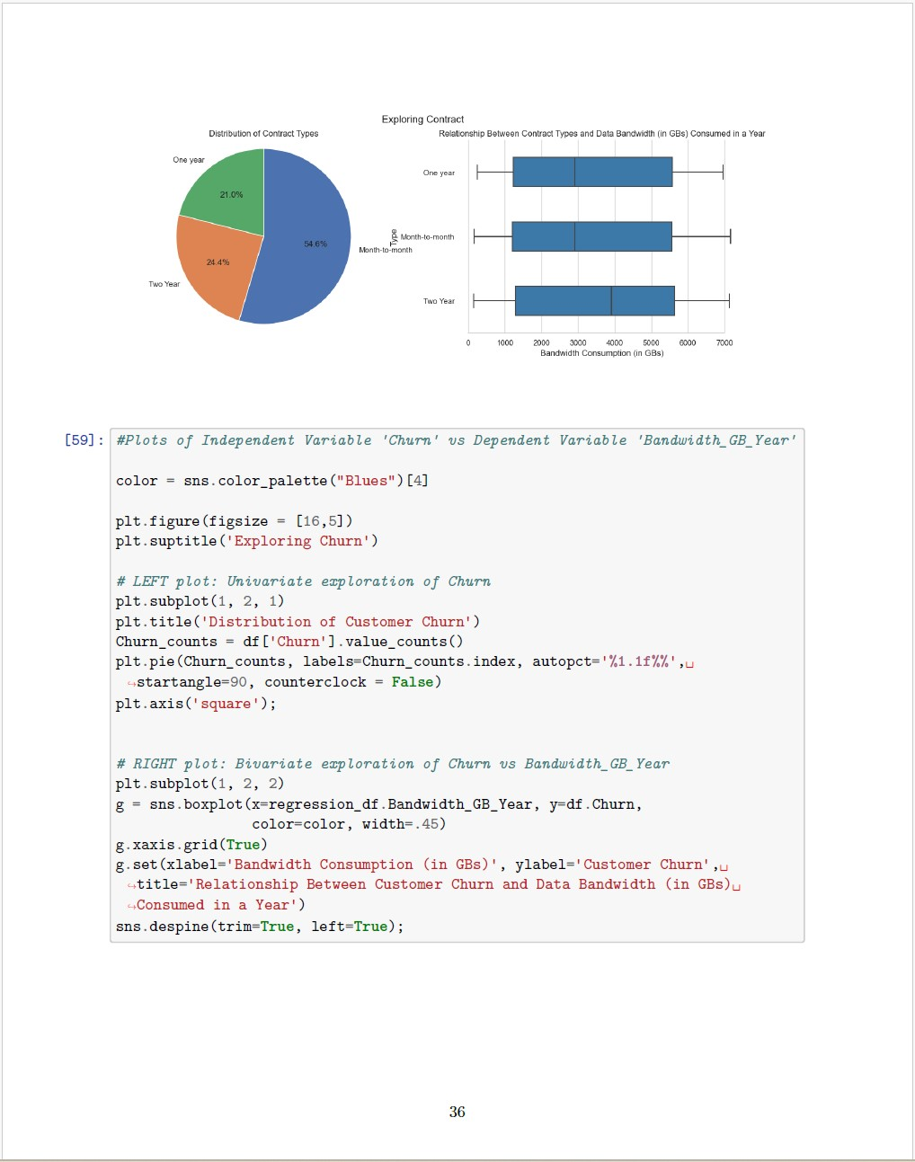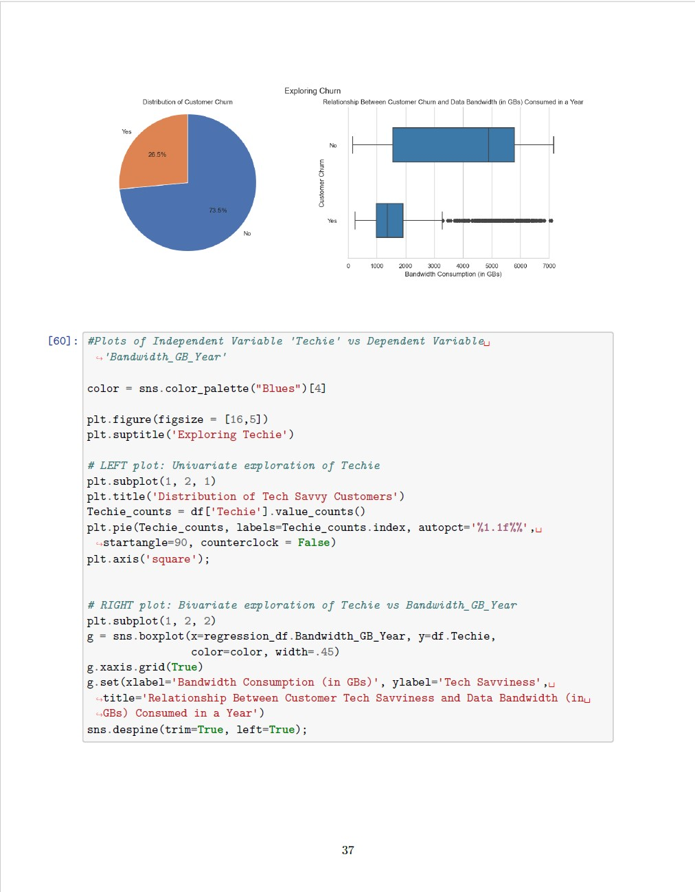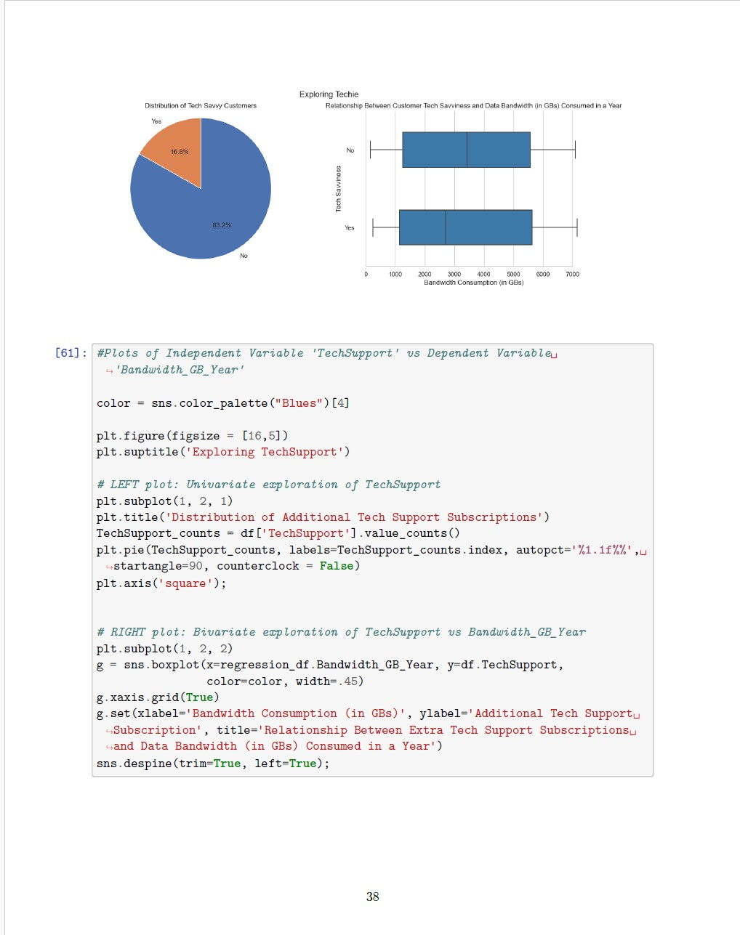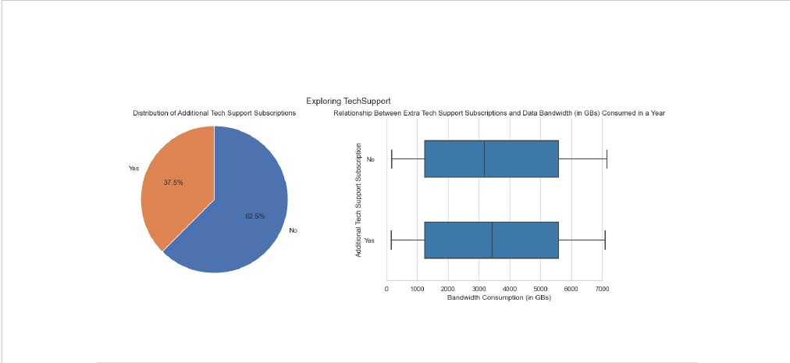

**C4:DATA TRANSFORMATION (COMBINED WITH C1: DATA CLEANING IN A PRIOR SECTION)**

This section was concurrently completed during the data cleaning process and outlined in an earlier section above.

**C5: PREPARED DATA SET**

Also mentioned in a prior section that combined data cleaning and data transformation, two versions of the prepared data sets were created. A cleaned version prior to RobustScaler transformation on outliers and a cleaned version after its outliers have been transformed by RobustScaler. The code used to create both data sets is listed below.

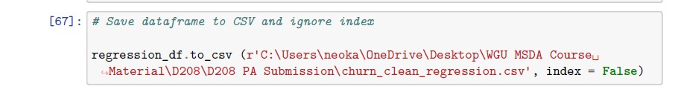

**D1: INITIAL MODEL**

The initial Multiple Linear Regression (MLR) Model was constructed with the dependent variable ‘Bandwidth_GB_Year’ and the 12 independent variables: ‘InternetService, ‘Area’, ‘Contract’, ‘Churn’, ‘Techie’, ‘TechSupport’, ‘Income’, ‘Tenure’, ‘MonthlyCharge’, ‘Outage_sec_perweek’, ‘Population’, ‘Age’.

A y-intercept was generated in this initial model by using the .assign(const=1) function. Prior to running the initial model, a check for the VIF of each independent variable was performed in order to rule out high levels of multicollinearity. No VIF was greater than 10, therefore, no further analyses or removal of any independent variable was necessary.

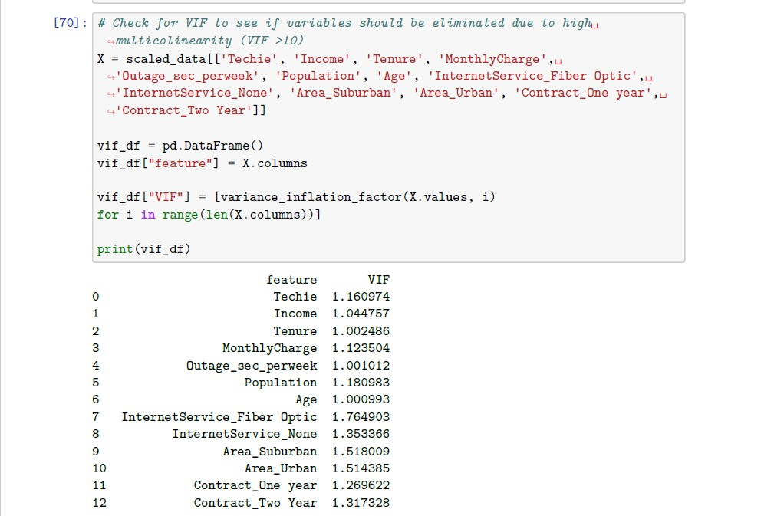

After running the initial model, the summary shows that the model is a good fit for the data due to the low RSE value of 0.022. This is also supported by the r-squared value of 0.998, signifying that a large proportion of the variance in the dependent variable is explained by the independent variables included in the model. Additionally, a high f-statistic value of 3.929e+05 and the low f-statistic probability 0.00 show that the initial model is statistically significant (McAleer, *Interpreting linear regression through statsmodels .summary()* 2020). Attached below is the code and summary for the initial MLR model.

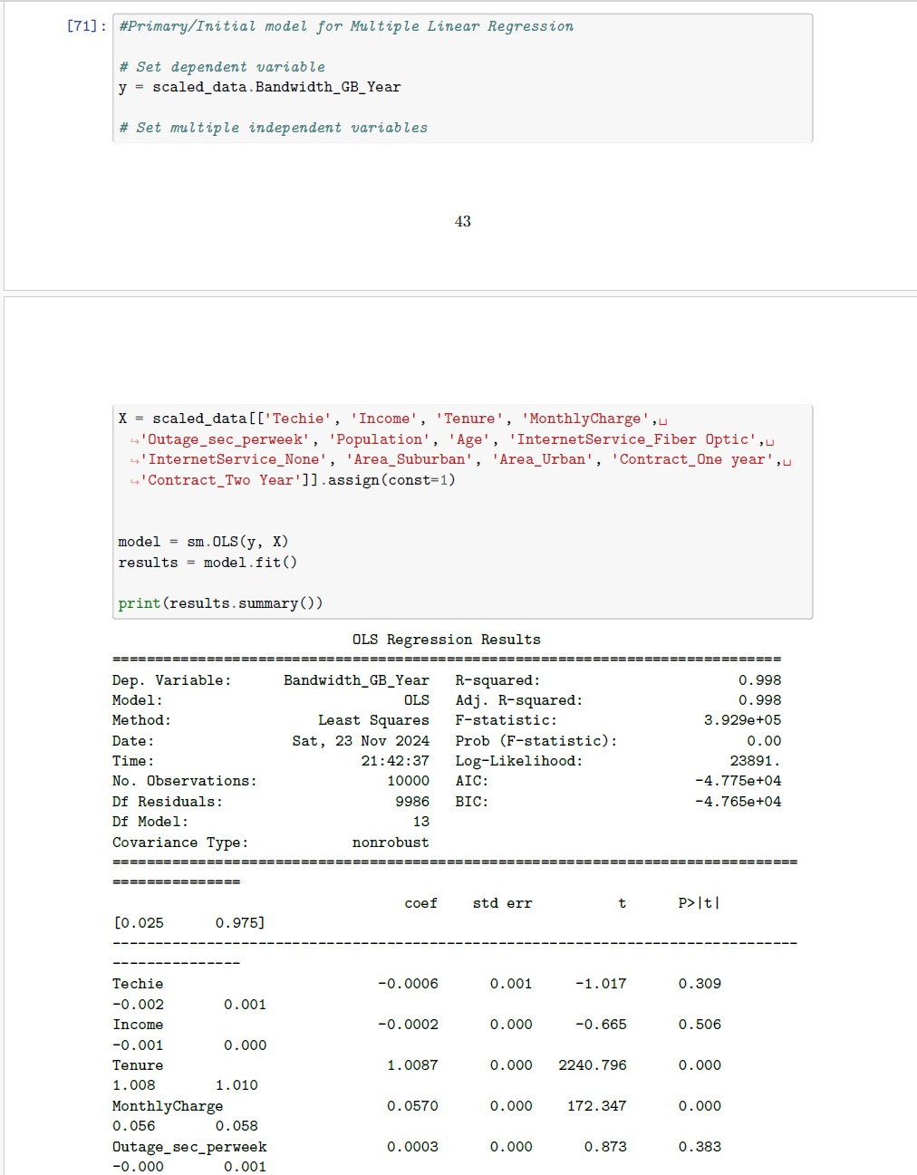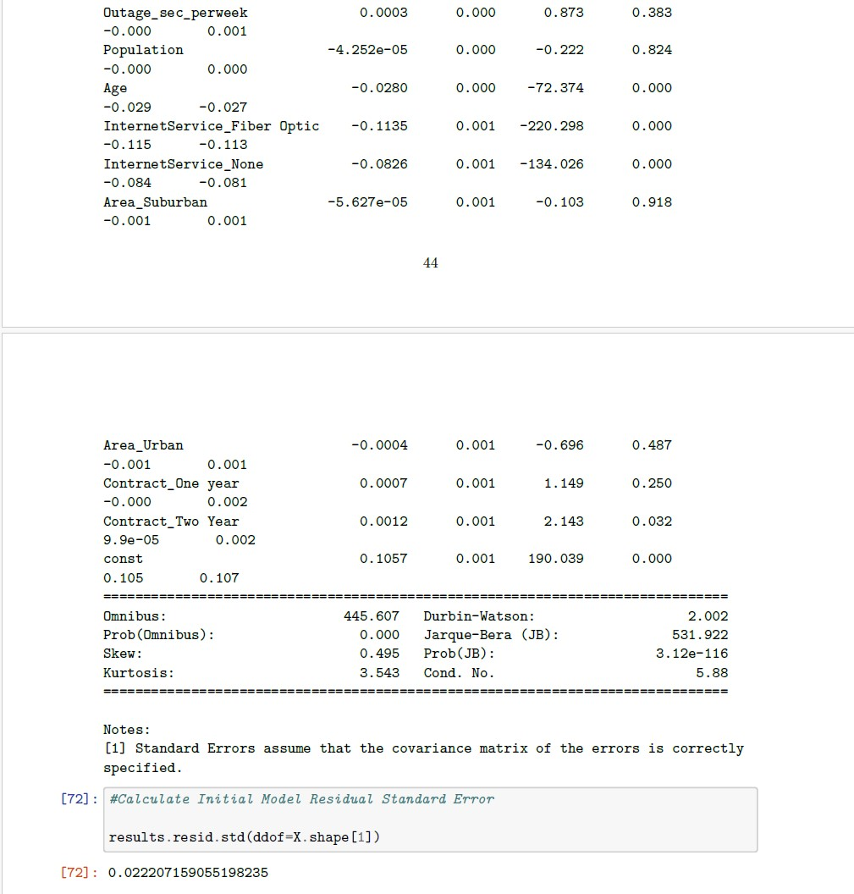

**D2: JUSTIFICATION OF MODEL REDUCTION**

Although our initial model is already a good fit for the data and statistically significant, an attempt to further improve it via forward selection was performed, resulting in keeping only the features with p-values < 0.05, the alpha. The following independent variables were the resulting selected features after forward selection was performed: 'Tenure', 'MonthlyCharge', 'InternetService_Fiber Optic', 'InternetService_None', and 'Age'. 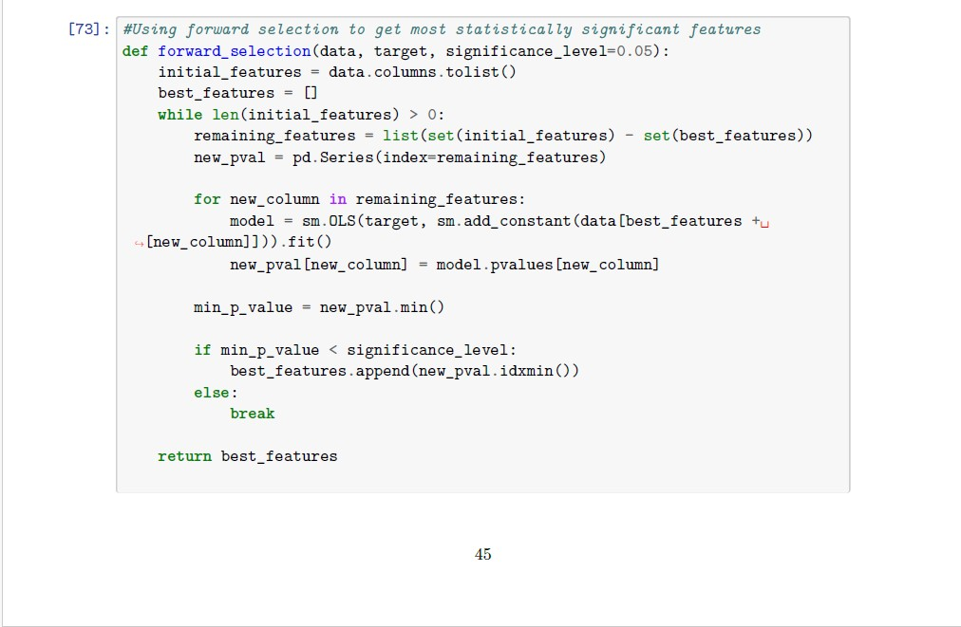

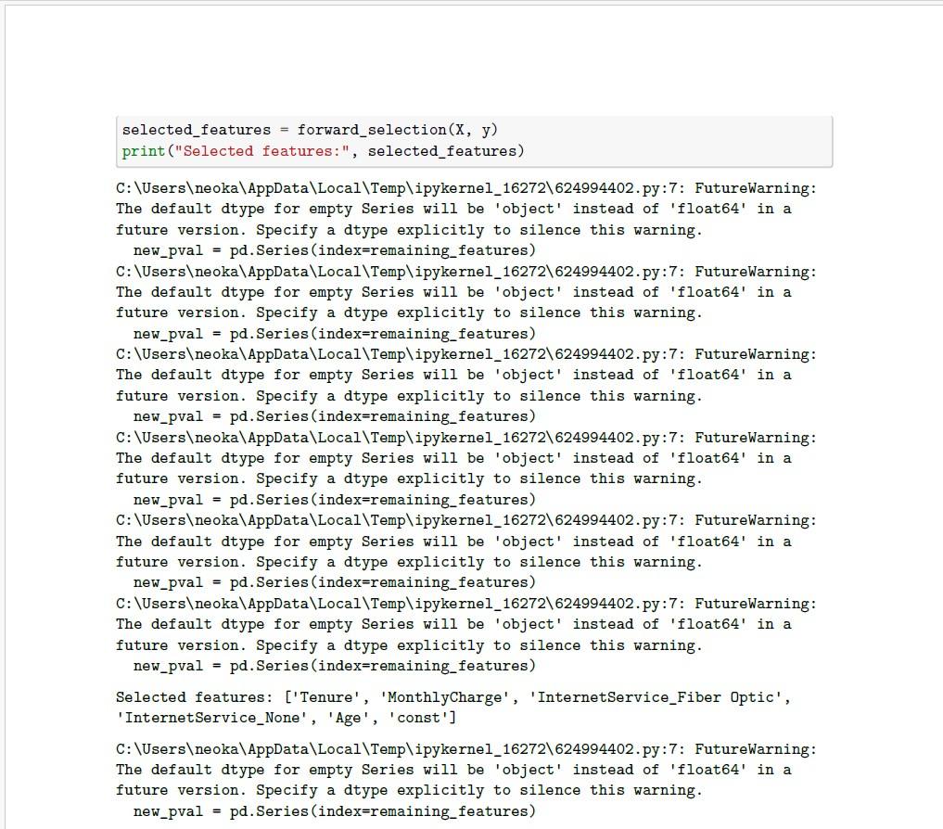

Next, the reduced model was constructed and run with only the remaining selected features. 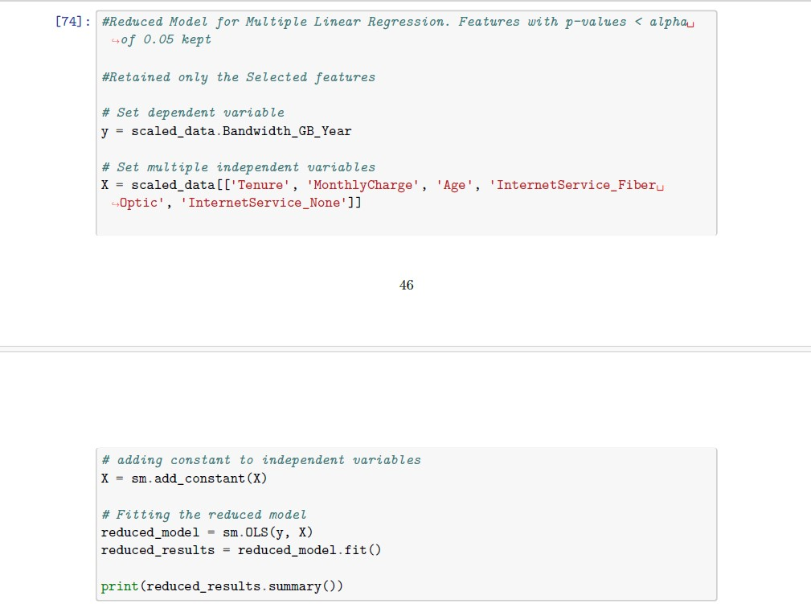

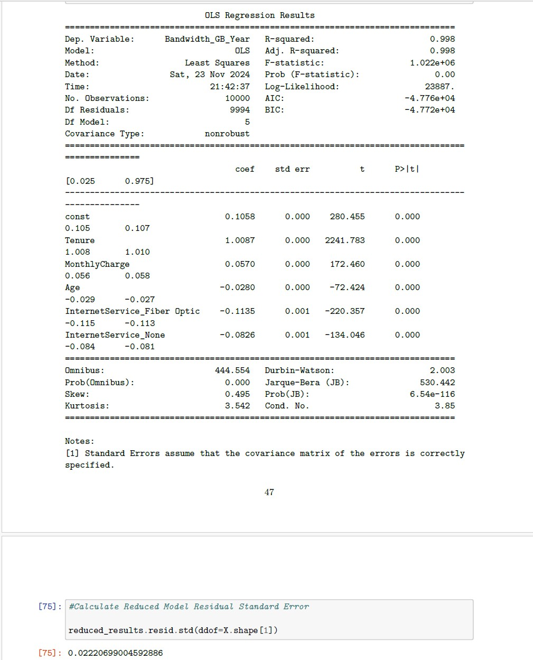

An analysis of the summary statistics such as the r-squared value, f-statistic value, f-statistic probability of 0.00, and the RSE for the reduced model still show that the model is a good fit and is statistically significant.

**D3: REDUCED LINEAR REGRESSION MODEL**

Given the analyses of summary statistics discussed above on the reduced model, this version is the final reduced MLR model. Attached below is the code and statistical summary of the final model. 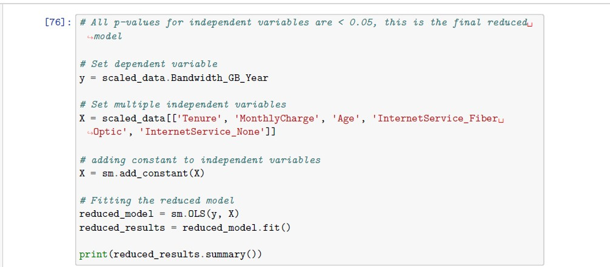

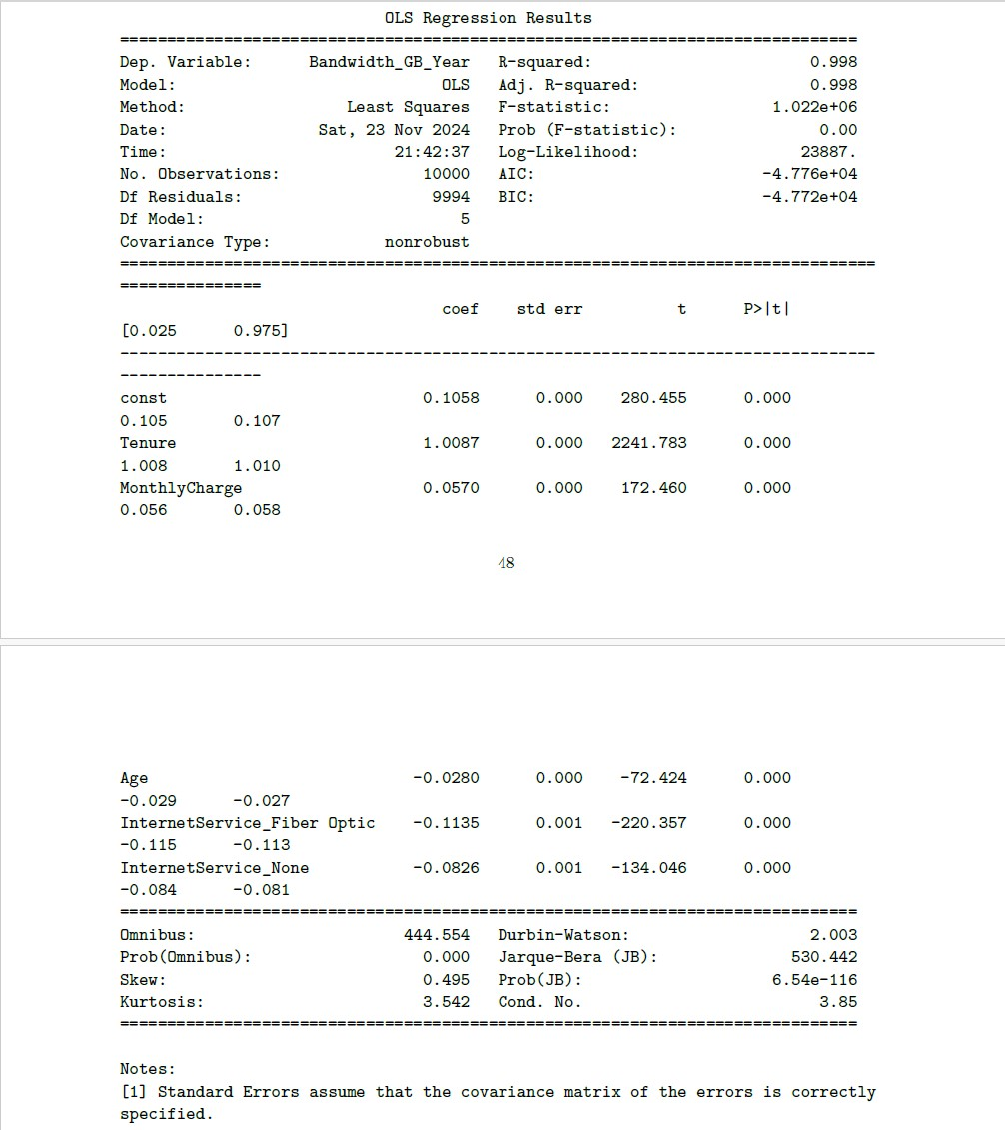

**E1: MODEL COMPARISON**

Both the initial model and reduced models show summary statistics that indicate statistical significance based on the r-squared value, f-statistic value, f-statistic probability of 0.00, and low RSE value. Additionally, low AIC scores for both models further support that the model is a good fit for the data. Either model is statistically significant, however, choosing the reduced one would be better since it can achieve similar summary scores with fewer features/predictor variables.

Additionally, White’s test for heteroscedasticity was conducted on the reduced model and returned a p-value less than the alpha of 0.05. Therefore, heteroscedasticity is present in this model, leading us to reject the null hypothesis (Bobbitt, *How to perform white's test in Python (STEP-by-step)* 2021). Also, all the selected features in the reduced model are statistically significant due to their individual p-values being less than the alpha 0.05. Finally, the f-statistics and f-statistic probability further support that the reduced model is considered statistically significant.

Also included are residual plots of the dependent variable vs each of the independent variables that remained as a selected feature ('Tenure', 'MonthlyCharge', 'Age', 'InternetService_Fiber Optic', and 'InternetService_None'). The following code encompasses all of the code used for both the initial and reduced models, RSE calculations, White’s test, and residual plots for both models. 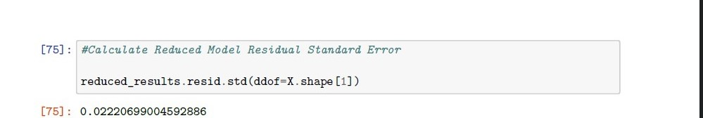

**E2: OUTPUT AND CALCULATION**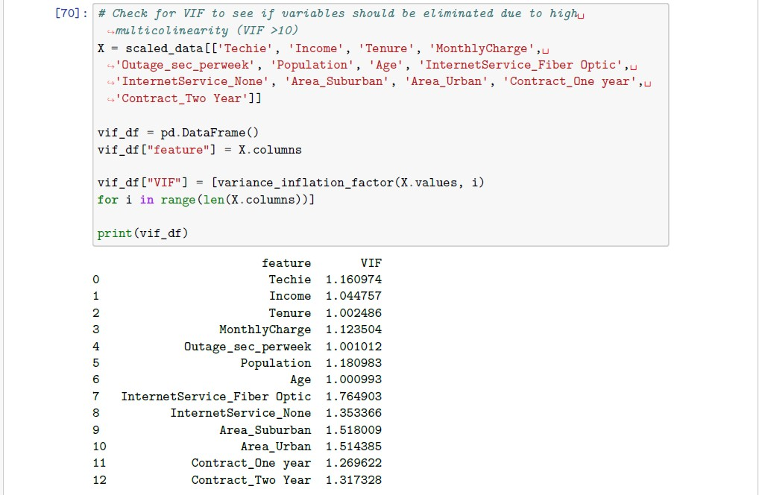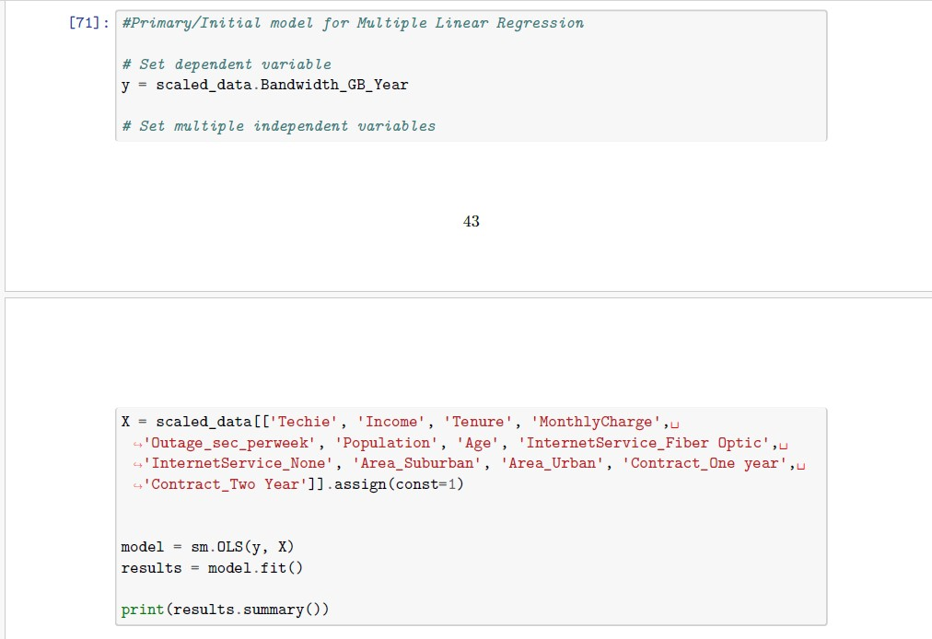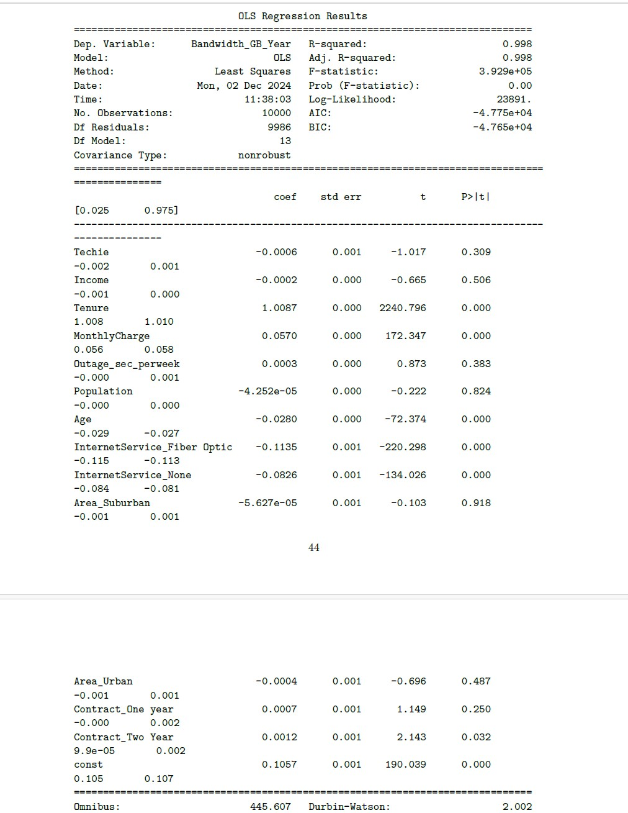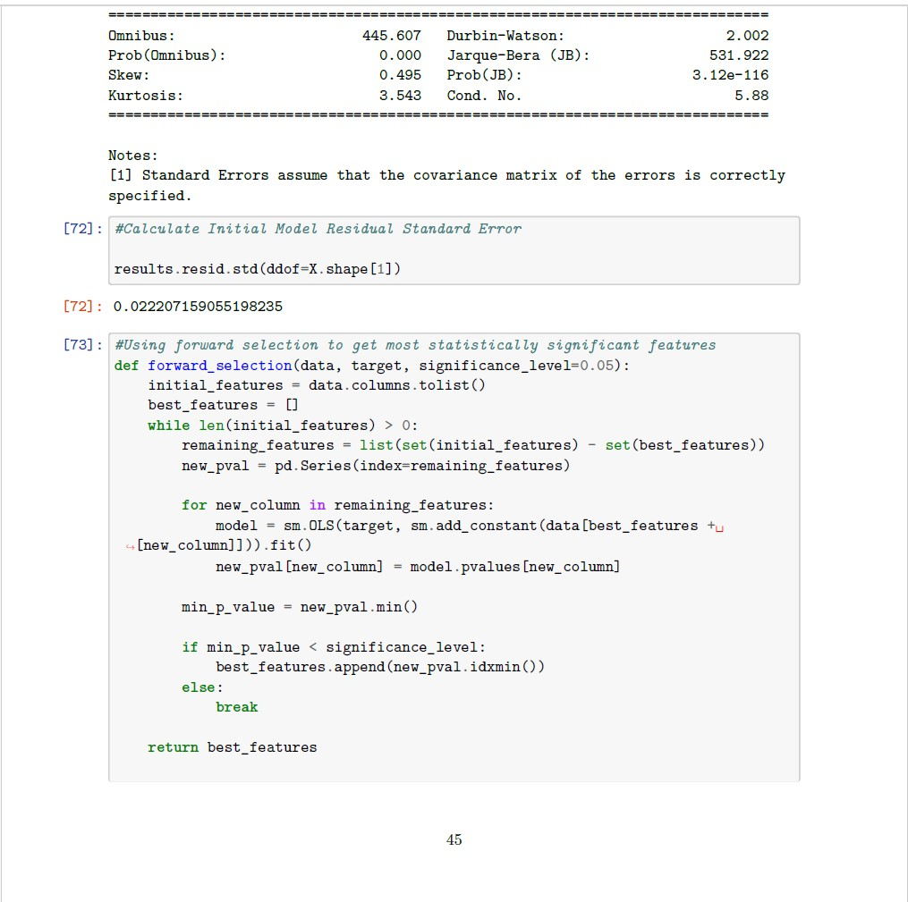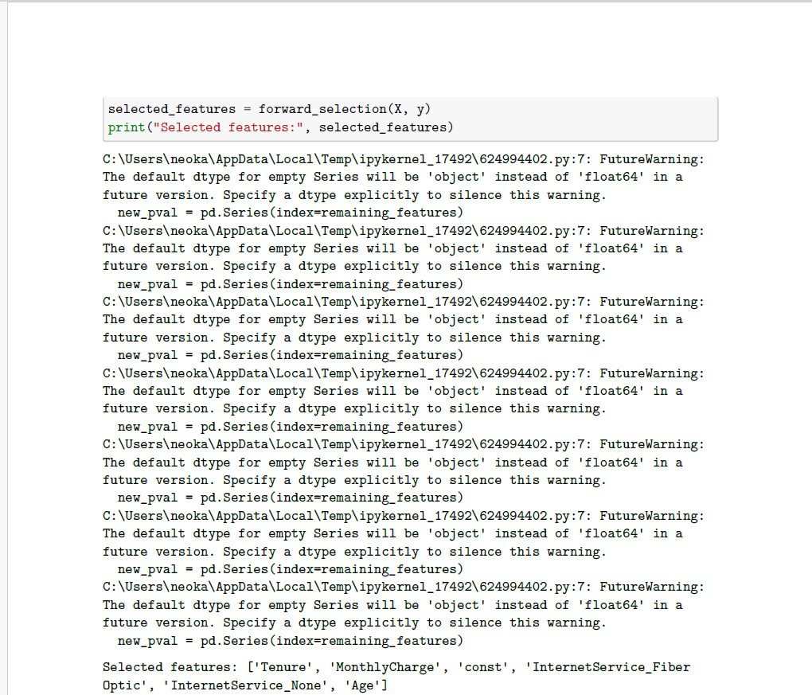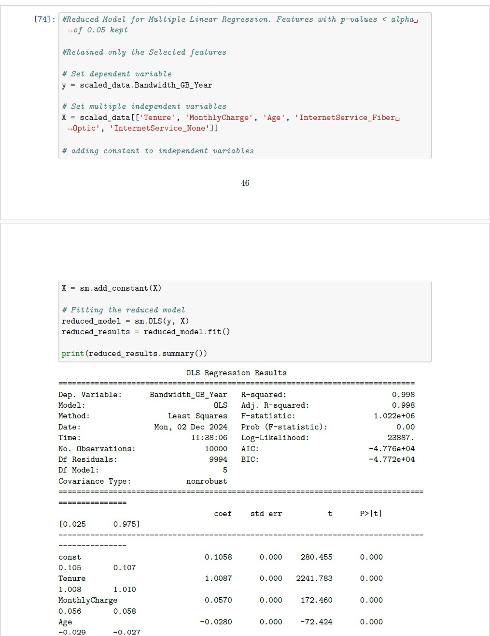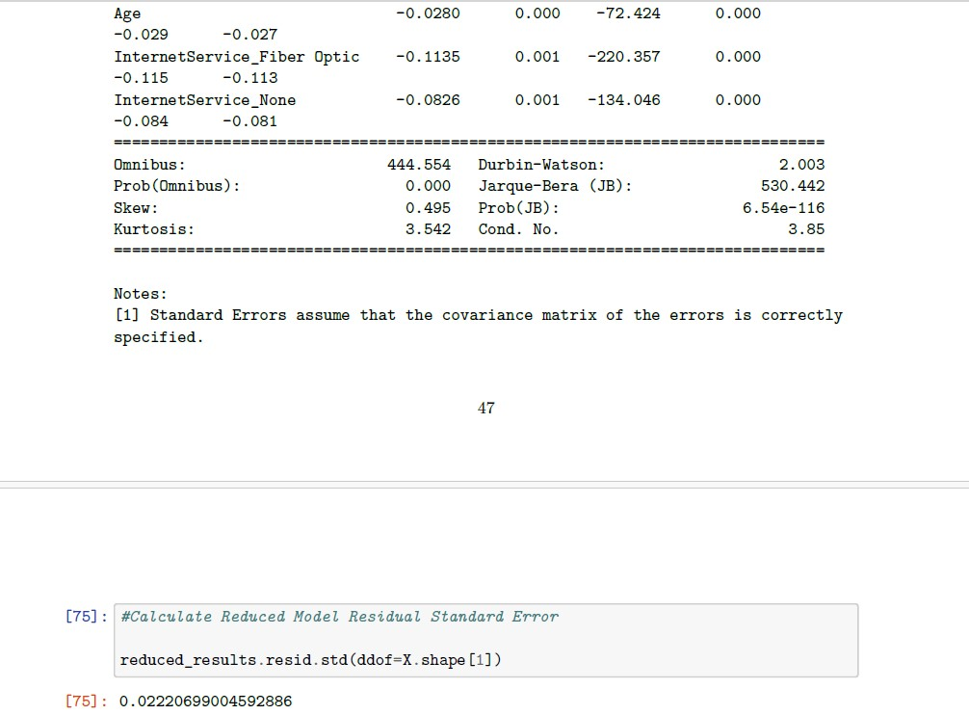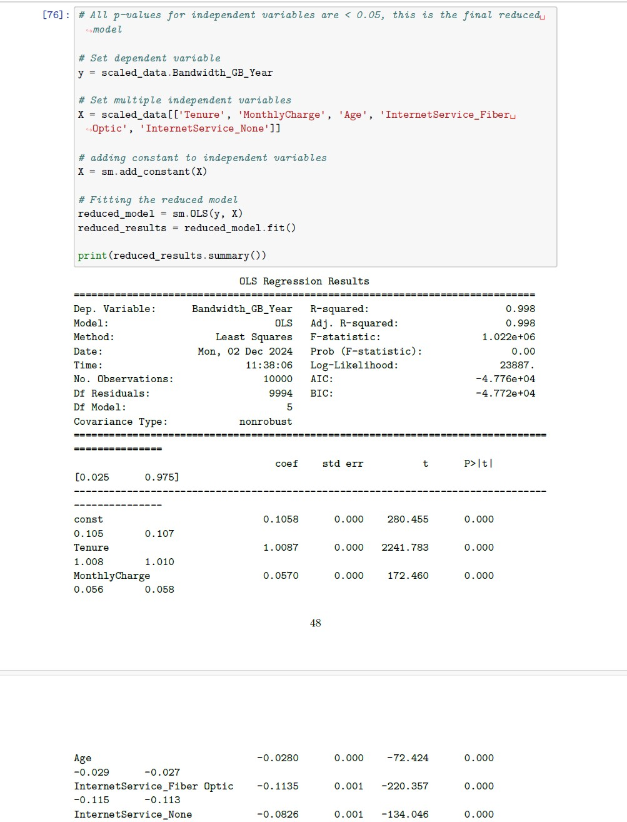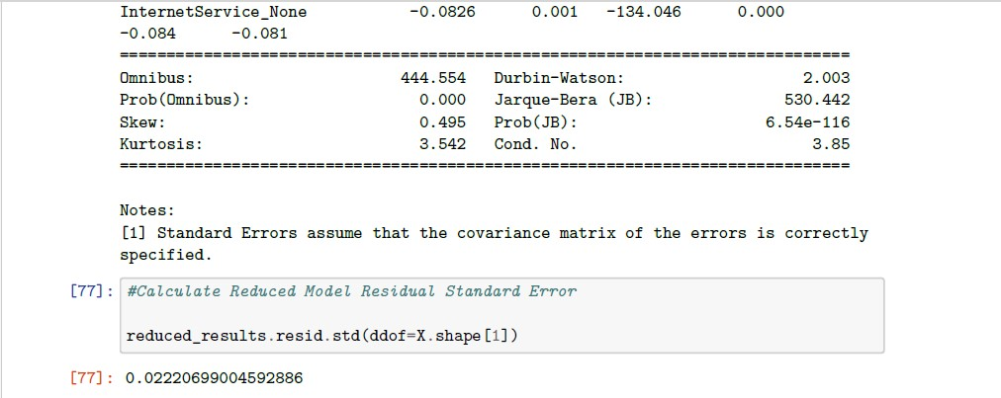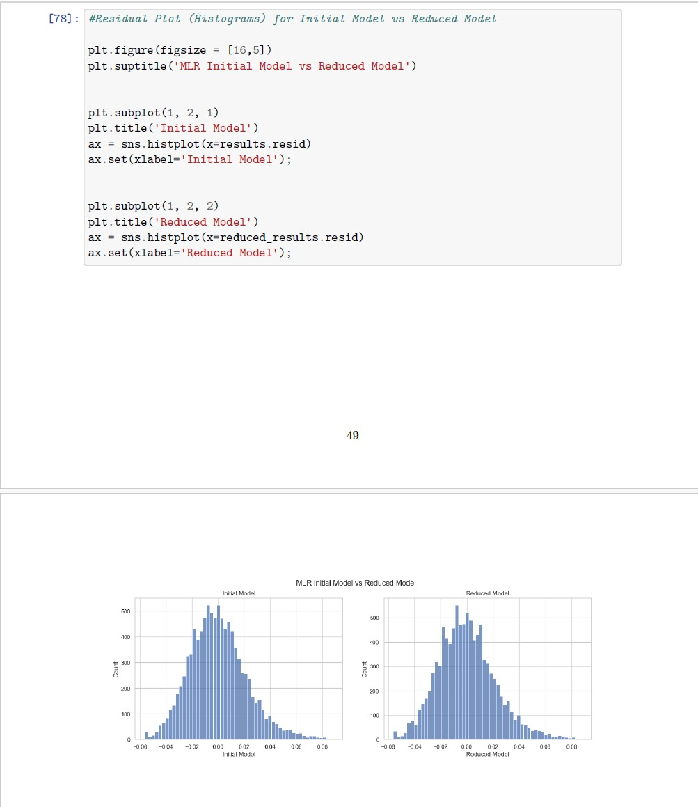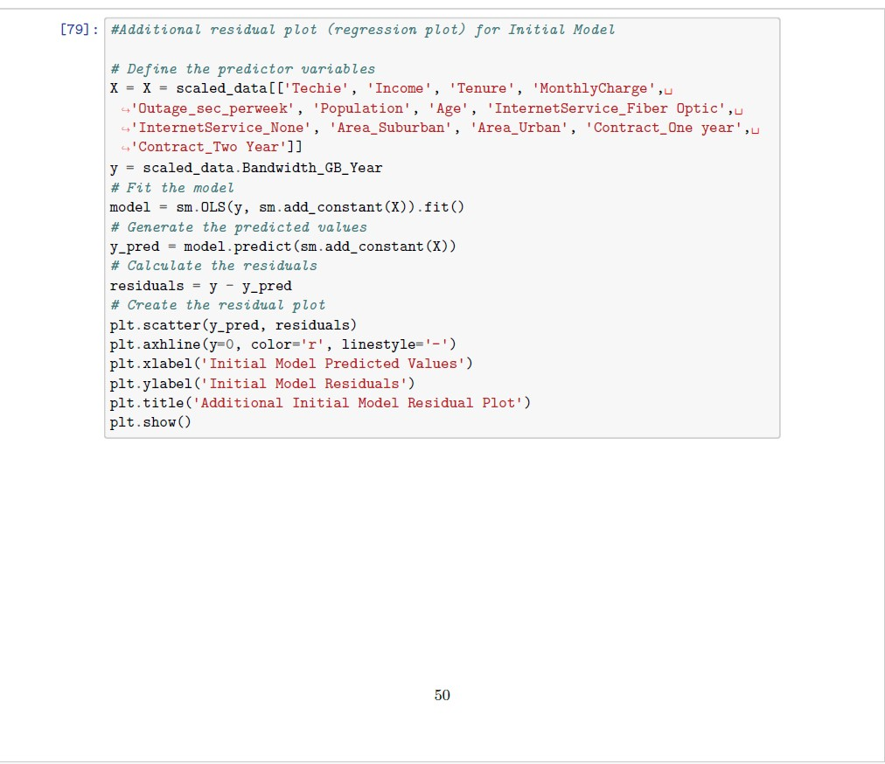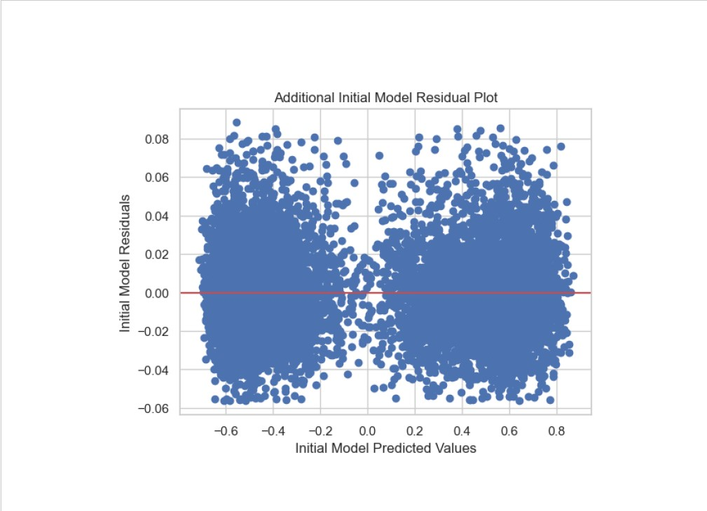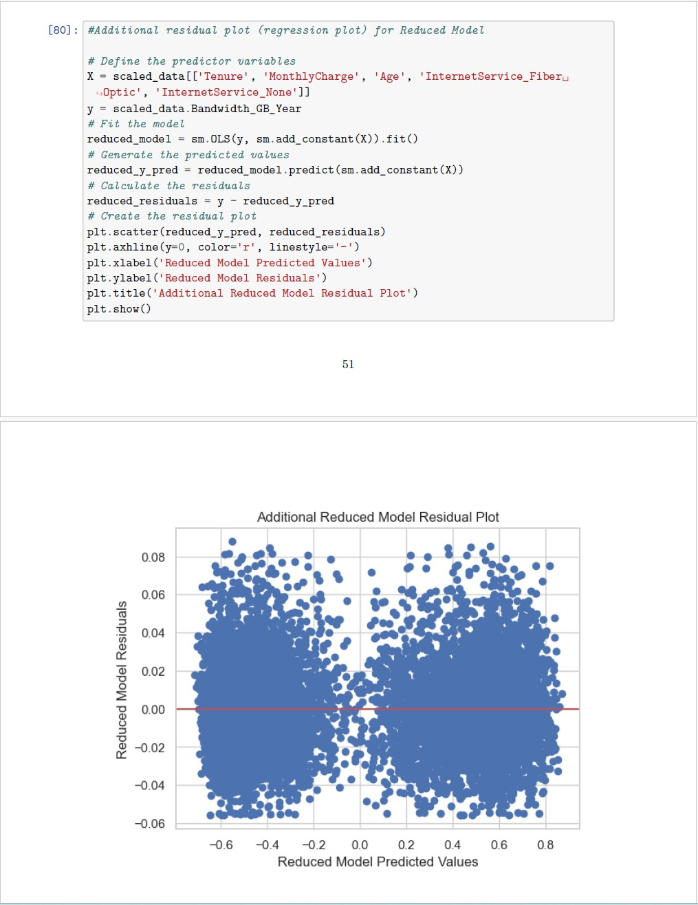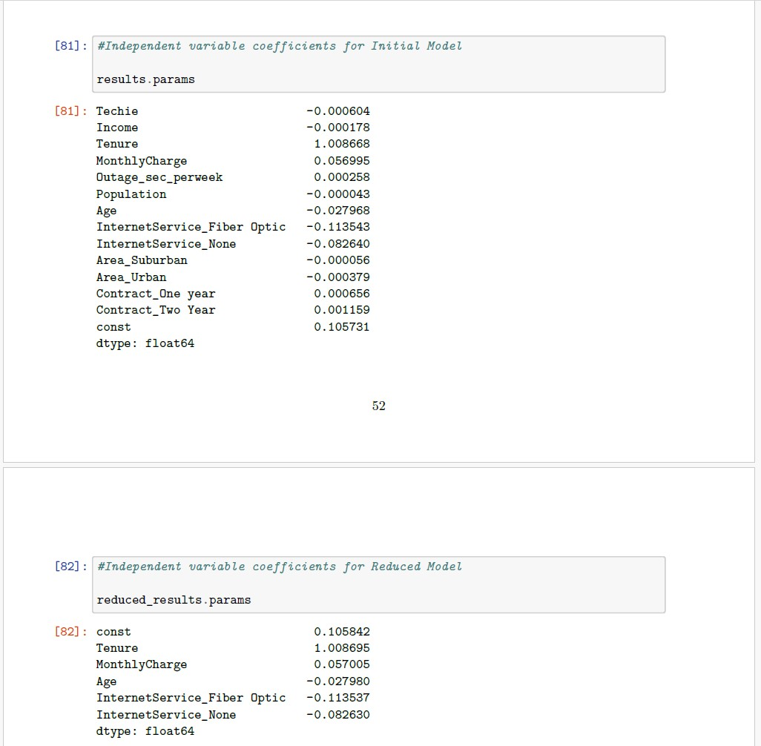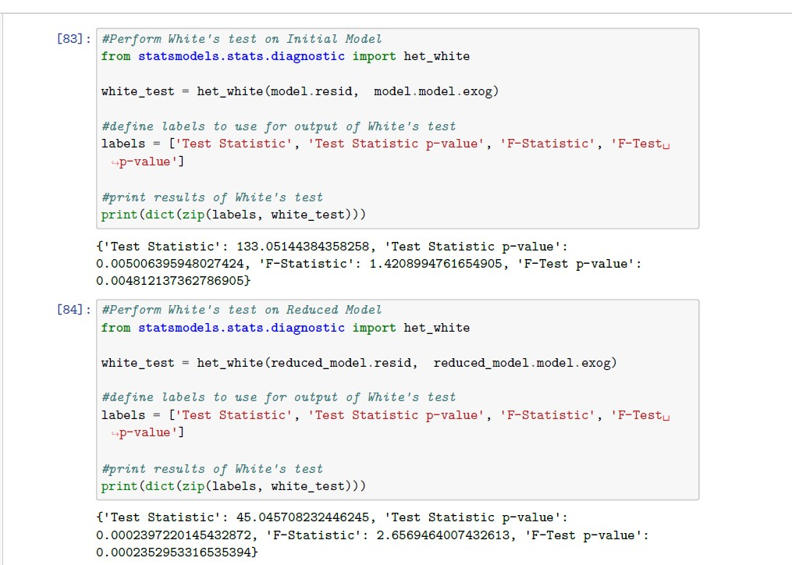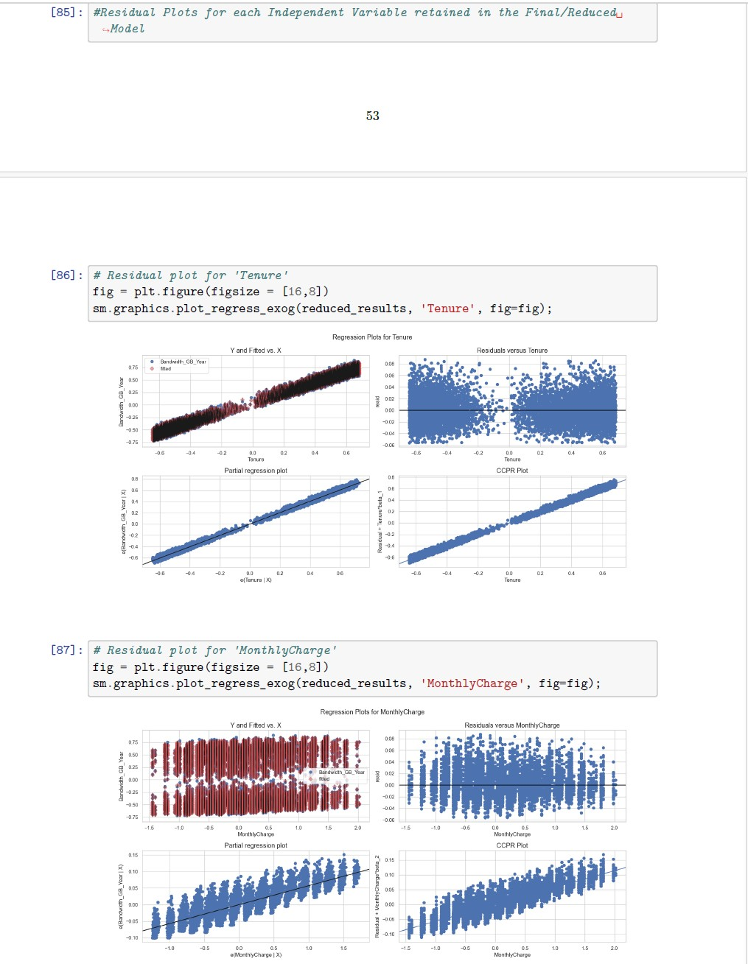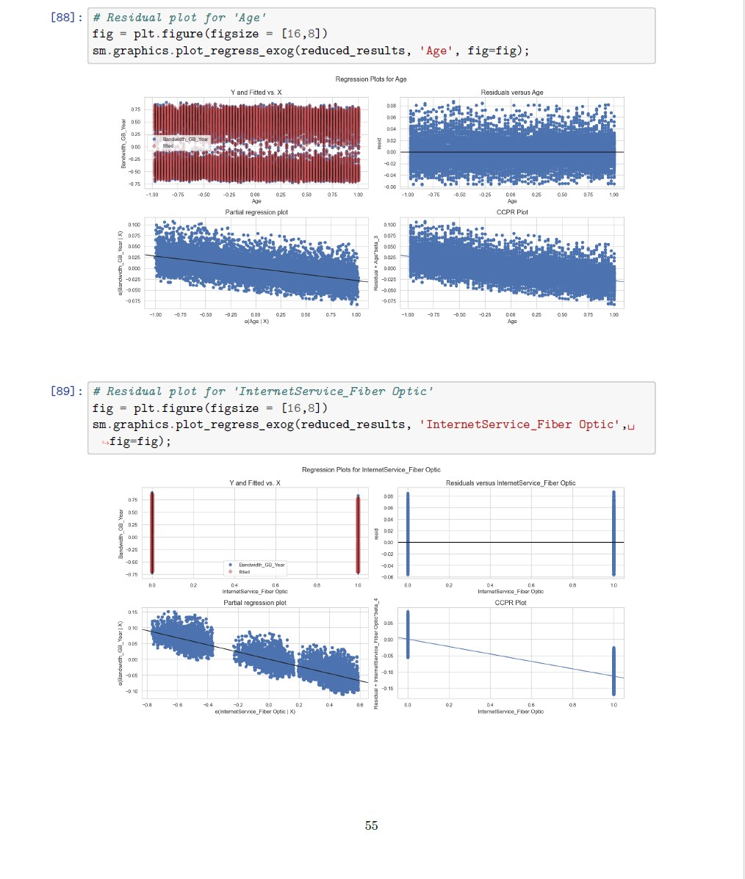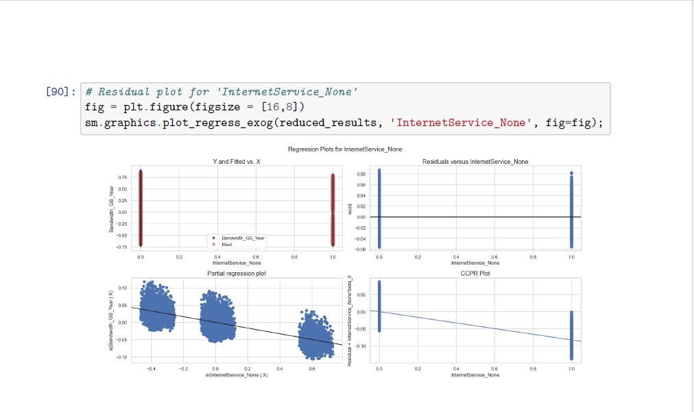

**E3: CODE**

A copy of the code written in a Jupyter Notebook will be included as an attachment in my submission.

**F1: RESULTS**

* **Regression Equation**: Y = B0 + B1X1 + B2X2 + B3X3 + ... + BnXn
  + Bandwidth_GB_Year = const + Tenure + MonthlyCharge + Age + InternetService_Fiber Optic + InternetService_None
    - Bandwidth_GB_Year = 0.1058 + 1.0087 + 0.0570 - 0.0280 - 0.1135 - 0.0826

Given the equation structure, if all other variables are zero, the constant is the estimated value of Bandwidth_GB_Year, approximately 0.1058. Tenure shows the strongest relationship with our dependent variable, increasing it by 1.0087 if all other variables are held constant. MonthlyCharge also contributes to increasing the dependent variable, albeit at a much weaker relationship of 0.0570 units. Age, InternetService_Fiber Optic, and InternetService_None all have negative relationships with the dependent variable, implying that these variables have an association with lower bandwidth consumption per year.

* **Statistical and Practical Significance**
  + Based off the r-squared value, f-statistic value, f-statistic probability of 0.00, and low RSE value, the reduced model is statistically significant. Practically, the reduced model can prove useful in predicting bandwidth consumed per year by based on a customer’s tenure.
* **Limitations of Analysis**
  + Some limitations of this analysis and dataset are the fact that there’s no category for bandwidth speed tiers. Furthermore, I think that it would provide greater insight if the dataset had a categorical variable that could identify the primary usage of bandwidth such as business, media, gaming, etc.

**F2: RECOMMENDATIONS**

Based on the reduced model, those with longer tenure tend to consume higher amounts of bandwidth per year. Therefore, encouraging a customer to stay subscribed instead of churning is a good base target to formulate a service campaign. For example, enticing a customer with package deals or customer loyalty discounts and/or bundles could lead to subscriptions to the higher priced premium tiers of service. These premium packages could then be structured in such a way that it comes with higher bandwidth speeds and bandwidth allotments.

**G: PANOPTO DEMONSTRATION**

<https://wgu.hosted.panopto.com/Panopto/Pages/Viewer.aspx?id=bd2eb5b8-7c6d-412f-9f61-b23a015adffa>

**H: SOURCES OF THIRD-PARTY CODE**

Abolirm. (2023, May 9). Feature scaling - part 3. GeeksforGeeks. https://www.geeksforgeeks.org/feature-scaling-part-3/

Bobbitt, Z. (2021, November 29). *How to perform white’s test in Python (STEP-by-step)*. Statology. https://www.statology.org/white-test-in-python/

Lekhana_Ganji. (2024, November 2). One hot encoding in machine learning. GeeksforGeeks. https://www.geeksforgeeks.org/ml-one-hot-encoding/

**I: SOURCES**

Abolirm. (2023, May 9). Feature scaling - part 3. GeeksforGeeks. https://www.geeksforgeeks.org/feature-scaling-part-3/

Bobbitt, Z. (2021, November 29). *How to perform white’s test in Python (STEP-by-step)*. Statology. https://www.statology.org/white-test-in-python/

Hayes, A. (n.d.). Multiple linear regression (MLR) definition, formula, and example. Investopedia. https://www.investopedia.com/terms/m/mlr.asp

Lekhana_Ganji. (2024, November 2). One hot encoding in machine learning. GeeksforGeeks. https://www.geeksforgeeks.org/ml-one-hot-encoding/

McAleer, T. (2020, December 14). Interpreting linear regression through statsmodels .summary(). Medium. https://medium.com/swlh/interpreting-linear-regression-through-statsmodels-summary-4796d359035a

Multiple linear regression. Corporate Finance Institute. (2024, July 10). https://corporatefinanceinstitute.com/resources/data-science/multiple-linear-regression/